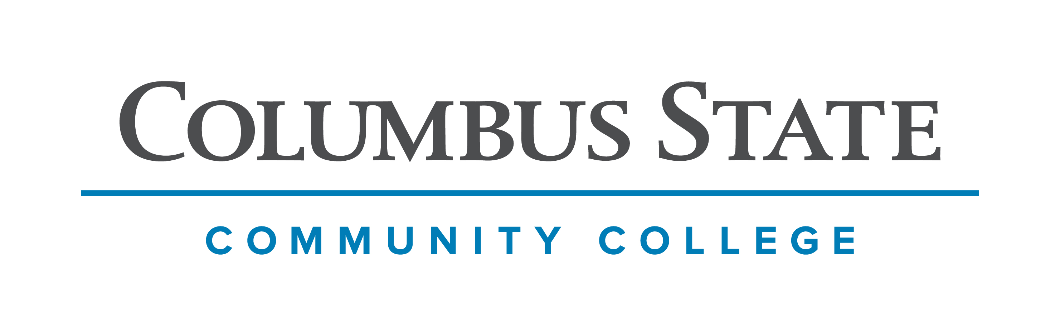
Columbus State Community College & West Virginia University
Associate of Arts leading to
Bachelor of Arts- International Studies (WVU-BA)
Suggested Plan of Study
Columbus State Community College | Hours | WVU Equivalents | Hours
Year One, 1st Semester
ENGL 1100 or ENGL 1101 | 3 | ENGL 101 | 3
MATH 1148 | 4 | MATH 126 | 4
HIST 1112 | 3 | HIST 102 | 3
Visual/Performing Arts | 3 | Visual/Performing Arts | 3
A.A Elective | 3 | A.A Elective | 3
COLS 1100 or COLS 1101 | 1 | ORIN 1TC | 1
TOTAL | 17 |  | 17
Year One, 2nd Semester
ENGL 2367 | 3 | ENGL 102 | 3
HIST 1182 | 3 | HIST 180 | 3
Visual/Performing Arts | 3 | Visual/Performing Arts | 3
POLS 1300 | 3 | POLS 260 | 3
Social and Behavioral Science Elective | 3 | Social and Behavioral Science Elective | 3
TOTAL | 15 |  | 15
Year Two, 1st Semester
Natural Science with Lab | 4 | Natural Science with Lab | 4
ECON 2200 | 3 | ECON 201 | 3
FOR LANG 1101 | 4 | FOR LANG 101 | 4
A.A Elective | 3 | A.A Elective | 3
ASC 1190 | 1 | PHIL 1TC | 1
TOTAL | 15 |  | 15
Year Two, 2nd Semester
Natural Science (No Lab) | 3 | Natural Science (No Lab) | 3
GEOG 2300 or 2750 or POLS 1200^ | 3 | GEOG 107 or 102 or POLS 250 | 3
FOR LANG 1102 | 4 | FOR LANG 102 | 4
A.A Elective | 3 | A.A Elective | 3
A.A Elective | 1 | A.A Elective | 1
TOTAL | 14 |  | 14

WEST VIRGINIA UNIVERSITY
Year Three, 1st Semester |  | Year Three, 2nd Semester
FOR LANG 203 | 3 | FOR LANG 204 | 3
AoE Course | 3 | AoE Course | 3
AoE Course | 3 | AoE Course | 3
AoE Course | 3 | AoE Course | 3
General Elective | 3 | General Elective | 3
TOTAL | 15 | TOTAL | 15
Year Four, 1st Semester |  | Year Four, 2nd Semester
AoE Course | 3 | INTS 488 | 3
AoE Course | 3 | AoE Course | 3
AoE Course | 3 | AoE Course | 3
General Elective | 3 | AoE Course | 3
General Elective | 3 | General Elective | 2
TOTAL | 15 | TOTAL | 14

Students who wish greater flexibility in Regional Course options should consider beginning a foreign language sequence prior to transferring to West Virginia University. Consultation with an academic advisor within the Eberly College Undergraduate Affairs Office is recommended prior to selecting a foreign language.

Students completing degrees from the WVU Eberly College of Arts and Sciences are encouraged to work with their advisors to integrate completion of an academic minor or minors into their programs of study. WVU offers over 100 minors that complement major fields of study, build on students’ unique interests, expand perspectives, and broaden skills. See http://catalog.wvu.edu/undergraduate/minors/#minorsofferedtext for a list of available minors. Columbus State Community College students may begin completion of certain minors at CSCC by utilizing elective hours to take courses equivalent to the minor’s introductory requirements at WVU.

Students transferring to West Virginia University with an Associate of Arts or Associate of Science degree will have satisfied the General Education Foundation requirements at WVU.

Students who have questions regarding this articulation agreement or the transferability of coursework may contact the WVU Office of the University Registrar. All other questions should be directed to the WVU Office of Admissions.

The above transfer articulation of credit between West Virginia University and Columbus State Community College, is approved by the Dean, or the Dean’s designee, and effective the date of the signature.

____________________________________ ____________________________________ _______________
Print Name Signature Date

Valerie Lastinger Ph.D. Associate Dean for WVU’s Eberly College of Arts & Sciences

