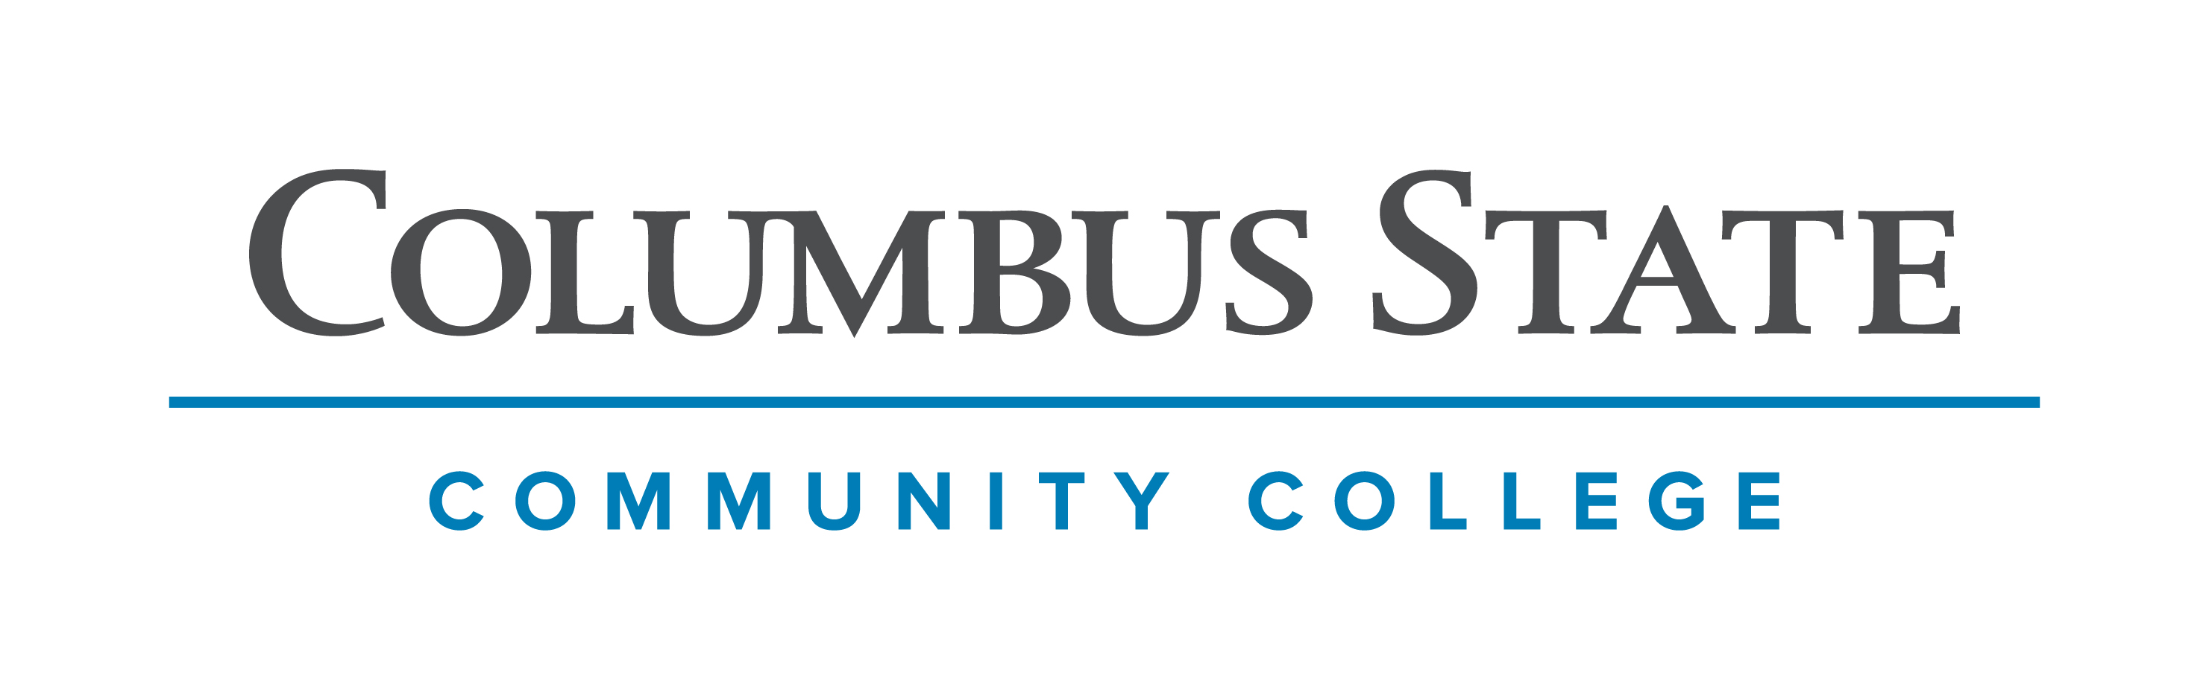
Columbus State Community College & West Virginia University
Associate of Science leading to
Bachelor of Science- Chemistry (WVU-BS)
Suggested Plan of Study
Columbus State Community College | Hours | WVU Equivalents | Hours
Year One, 1st Semester
ENGL 1100 or ENGL 1101 | 3 | ENGL 101 | 3
MATH 1151 | 5 | MATH 155 | 5
CHEM 1171 | 5 | CHEM 115 + CHEM 115L | 5
COLS 1100 or COLS 1101 | 1 | ORIN 1TC | 1
ASC 1190 | 1 | PHIL 1TC | 1
TOTAL | 15 |  | 15
Year One, 2nd Semester
ENGL 2367 | 3 | ENGL 102 | 3
MATH 1152 | 5 | MATH 156 | 5
CHEM 1172 | 5 | CHEM 116 + CHEM 116L | 5
*Social & Behavioral Science | 3 | *Social & Behavioral Science | 3
TOTAL | 16 |  | 16
Year Two, 1st Semester
CHEM 2251 | 5 | CHEM 233 | 5
CHEM 2254 | 3 | CHEM 235 | 3
*Social & Behavioral Science Elective | 3 | *Social & Behavioral Science Elective | 3
*Visual/Performing Arts Elective | 3 | *Visual/Performing Arts Elective | 3
TOTAL | 14 |  | 14
Year Two, 2nd Semester
CHEM 2252 | 5 | CHEM 234 | 5
CHEM 2255 | 2 | CHEM 236 | 2
PHYS 1250 | 5 | PHYS 111 | 5
*Historical Study | 3 | *Historical Study | 3
TOTAL | 15 |  | 15

WEST VIRGINIA UNIVERSITY

Summer Session | PHYS 112 | 4

Year Three, 1st Semester |  | Year Three, 2nd Semester
CHEM 215 | 4 | AGBI 410 | 3
CHEM 335 | 4 | CHEM 310 | 3
CHEM 346 | 3 | CHEM 347 & CHEM 348 | 4
MATH 251 | 4 | Chemistry Elective 1 | 3
 |  | General Elective | 1
TOTAL | 15 | TOTAL | 14
Year Four, 1st Semester |  | Year Four, 2nd Semester
CHEM 349 | 2 | CHEM 401/CHEM 403 | 2
CHEM 313 | 1 | CHEM 423 | 2
ENGL 304/305 | 3 | Chemistry Elective 2 | 3
CHEM 422 | 3 | General Elective | 3
General Elective | 3 | General Elective | 3
General Elective | 3 | General Elective | 1
TOTAL | 15 | TOTAL | 14

Students who wish to graduate within a 4-year timeframe with a Bachelor of Science in Chemistry from WVU will need to enroll in PHYS 112 (or its equivalent) during the summer between their 2nd and 3rd year.

Students must complete CHEM 1171 & 1172 with a C or better to be admitted to the Chemistry program upon transferring to West Virginia University.

Students completing degrees in WVU’s Eberly College of Arts and Sciences are encouraged to work with their advisors to integrate completion of an academic minor or minors into their programs of study, to the degree allowed within elective hours. WVU offers over 100 minors that complement major fields of study, build on students’ unique interests, expand perspectives, and broaden skills. See http://catalog.wvu.edu/undergraduate/minors/#minorsofferedtext for a list of available minors. Columbus State students may begin completion of certain minors at CSCC by utilizing elective hours to take courses equivalent to the minor’s introductory requirements at WVU.

Students transferring to West Virginia University with an Associate of Arts or Associate of Science degree will have satisfied the General Education Foundation requirements at WVU.

Students who have questions regarding this articulation agreement or the transferability of coursework may contact the WVU Office of the University Registrar. All other questions should be directed to the WVU Office of Admissions.

The above transfer articulation of credit between West Virginia University and Columbus State Community College, is approved by the Dean, or the Dean’s designee, and effective the date of the signature.

_______________________________ _____________________________ ______________
Print Name Signature Date

Valerie Lastinger Ph.D. Associate Dean for WVU’s Eberly College of Arts & Sciences

