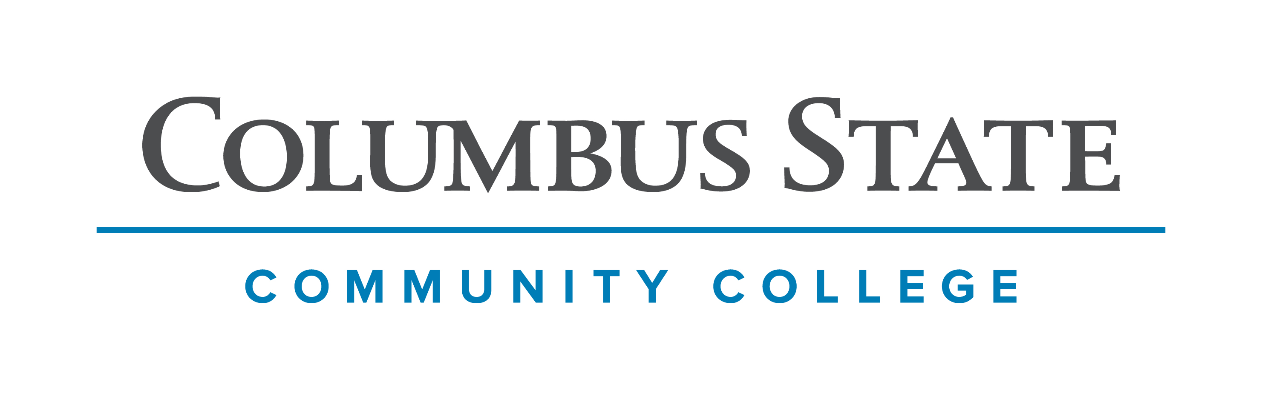
Columbus State Community College & West Virginia University
Associate of Arts leading to
Bachelor of Arts in Criminology (WVU-BA)
Suggested Plan of Study
Columbus State Community College | Hours | WVU Equivalents | Hours
Year One, 1st Semester
ENGL 1101 or ENGL 1100 | 3 | ENGL 101 | 3
MATH 1148 | 4 | MATH 126 | 4
SOC 1101 | 3 | SOCA 101 | 3
*Visual/Performing Arts Elective | 3 | Visual/Performing Arts Elective | 3
*Historical Study Elective | 3 | *Historical Study Elective | 3
COLS 1100 or 1101 | 1 | ORIN 1TC | 1
TOTAL | 17 |  | 17
Year One, 2nd Semester
ENGL 2367 | 3 | ENGL 102 | 3
STAT 1350 | 3 | STAT 211 | 3
SOC 2209 | 3 | SOCA 234 | 3
*Social & Behavioral Science Elective | 3 | *Social & Behavioral Science Elective | 3
**SOC 2202 or 2330 or 2380 or ANTH 2200 or 2202 | 3 | SOCA 207 or 221 or 235 or 252 or 254 | 3
TOTAL | 15 |  | 15
Year Two, 1st Semester
*Natural Science with Lab | 4 | *Natural Science with Lab | 4
SOC 2410 | 3 | SOCA 232 | 3
*Visual/Performing Arts Elective | 3 | *Visual/Performing Arts Elective | 3
**SOC 2202 or 2330 or 2380 or ANTH 2200 or 2202 | 3 | SOCA 207 or 221 or 235 or 252 or 254 | 3
ASC 1190 | 1 | PHIL 1TC | 1
TOTAL | 14 |  | 14
Year Two, 2nd Semester
*Natural Science with Lab | 3 | *Natural Science with Lab | 3
*Historical Study Elective | 3 | *Historical Study Elective | 3
Approved AA Elective | 3 | Approved AA Elective | 3
Approved AA Elective | 3 | Approved AA Elective | 3
Approved AA Elective | 3 | Approved AA Elective | 3
TOTAL | 15 |  | 15

WEST VIRGINIA UNIVERSITY
Year Three, 1st Semester |  | Year Three, 2nd Semester
SOCA 105 | 3 | SOCA 311 | 3
SOCA 301 | 3 | Upper-Level Criminology Course | 3
Upper-Level Criminology Course | 3 | General Elective | 3
SOCA 361 | 1 | FOR LANG 102 | 3
General Elective | 2 | General Elective | 3
FOR LANG 101 | 3
TOTAL | 15 | TOTAL | 15
Year Four, 1st Semester |  | Year Four, 2nd Semester
Upper-Level Criminology Course | 3 | SOCA 488 | 3
General Elective | 3 | General Elective | 3
General Elective | 3 | General Elective | 3
General Elective | 3 | General Elective | 2
FOR LANG 203 | 3 | FOR LANG 204 | 3
TOTAL | 15 | TOTAL | 14

**Students should choose two of the listed course options to satisfy the Criminology program’s SOCA elective requirement.

Students transferring to West Virginia University as part of this Articulation Agreement will be admitted to the Criminology program upon transferring to WVU despite lacking the SOCA 105 requirement, , as long as they have a C or higher in SOC 1101 (WVU SOCA 101).

Students completing degrees in WVU’s Eberly College of Arts and Sciences are encouraged to work with their advisors to integrate completion of an academic minor or minors into their programs of study, to the degree allowed within elective hours. WVU offers over 100 minors that complement major fields of study, build on students’ unique interests, expand perspectives, and broaden skills. See http://catalog.wvu.edu/undergraduate/minors/#minorsofferedtext for a list of available minors. Columbus State students may begin completion of certain minors at CSCC by utilizing elective hours to take courses equivalent to the minor’s introductory requirements at WVU.

Students transferring to West Virginia University with an Associate of Arts or Associate of Science degree will have satisfied the General Education Foundation requirements at WVU.

Students who have questions regarding this articulation agreement or the transferability of coursework may contact the WVU Office of the University Registrar. All other questions should be directed to the WVU Office of Admissions.

The above transfer articulation of credit between West Virginia University and Columbus State Community College, is approved by the Dean, or the Dean’s designee, and effective the date of the signature.

_______________________________ _____________________________ ______________
Print Name Signature Date

Valerie Lastinger Ph.D. Associate Dean for WVU’s Eberly College of Arts & Sciences

