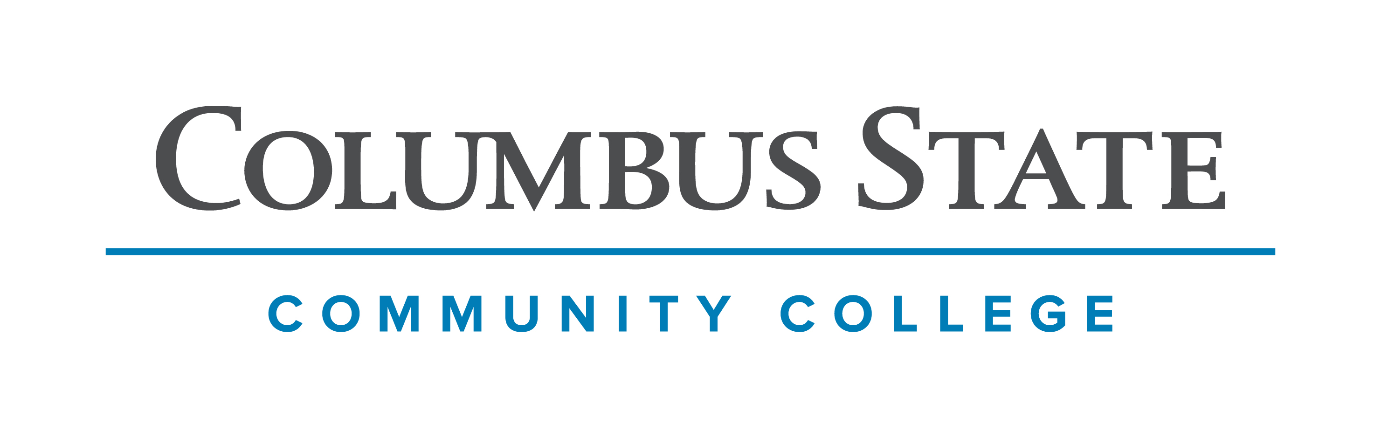
Columbus State Community College & West Virginia University
Associate of Science leading to
Bachelor of Arts- Physics (WVU-BA)
Suggested Plan of Study
Columbus State Community College | Hours | WVU Equivalents | Hours
Year One, 1st Semester
ENGL 1100 or ENGL 1101 | 3 | ENGL 101 | 3
MATH 1151 | 5 | MATH 155 | 5
Visual/Performing Arts | 3 | Visual/Performing Arts | 3
Historical Study Elective | 3 | Historical Study Elective | 3
COLS 1100 OR 1101 | 1 | ORIN 1TC | 1
TOTAL | 15 |  | 15
Year One, 2nd Semester
ENGL 2367 | 3 | ENGL 102 | 3
MATH 1152 | 5 | MATH 156 | 5
PHYS 1250 | 5 | PHYS 111 | 5
Social and Behavioral Science Elective | 3 | Social and Behavioral Science Elective | 3
TOTAL | 16 |  | 16
Year Two, 1st Semester
PHYS 1251 | 5 | PHYS 112 | 5
CHEM 1171 | 5 | CHEM 115 + CHEM 115L | 5
MATH 2153 | 5 | MATH 251 | 5
TOTAL | 15 |  | 15
Year Two, 2nd Semester
CHEM 1172 | 5 | CHEM 116 + CHEM 116L | 5
Social and Behavioral Science Elective | 3 | Social and Behavioral Science Elective | 3
MATH 2568 | 4 | MATH 343 | 4
ASC 1190 | 1 | PHIL 1TC | 1
A.S. Elective | 3 | A.S. Elective | 3
TOTAL | 16 |  | 16

WEST VIRGINIA UNIVERSITY
Year Three, 1st Semester |  | Year Three, 2nd Semester
FOR LANG 101 | 3 | FOR LANG 102 | 3
MATH 261 | 4 | PHYS 212 | 3
PHYS Elective | 3 | PHYS 314 | 4
PHYS Elective | 3 | General Elective | 3
General Elective | 3 | General Elective | 1
TOTAL | 16 | TOTAL | 14
Year Four, 1st Semester |  | Year Four, 2nd Semester
FOR LANG 203 | 3 | FOR LANG 204 | 3
PHYS Elective | 3 | PHYS 496 | 3
PHYS 341 | 1 | PHYS 341 | 1
General Elective | 3 | PHYS Elective | 3
General Elective | 3 | General Elective | 3
General Elective | 2 | General Elective | 1
TOTAL | 15 | TOTAL | 14

Students must have a GPA of 2.2 in all MATH and PHYS courses to be admitted to the Physics program upon transferring to West Virginia University.

Students completing degrees in WVU’s Eberly College of Arts and Sciences are encouraged to work with their advisors to integrate completion of an academic minor or minors into their programs of study, to the degree allowed within elective hours. WVU offers over 100 minors that complement major fields of study, build on students’ unique interests, expand perspectives, and broaden skills. See http://catalog.wvu.edu/undergraduate/minors/#minorsofferedtext for a list of available minors. Columbus State students may begin completion of certain minors at CSCC by utilizing elective hours to take courses equivalent to the minor’s introductory requirements at WVU.

Students transferring to West Virginia University with an Associate of Arts or Associate of Science degree will have satisfied the General Education Foundation requirements at WVU.

Students who have questions regarding this articulation agreement or the transferability of coursework may contact the WVU Office of the University Registrar. All other questions should be directed to the WVU Office of Admissions.

The above transfer articulation of credit between West Virginia University and Columbus State Community College, is approved by the Dean, or the Dean’s designee, and effective the date of the signature.

_______________________________ _____________________________ ______________
Print Name Signature Date

Valerie Lastinger Ph.D. Associate Dean for WVU’s Eberly College of Arts & Sciences

