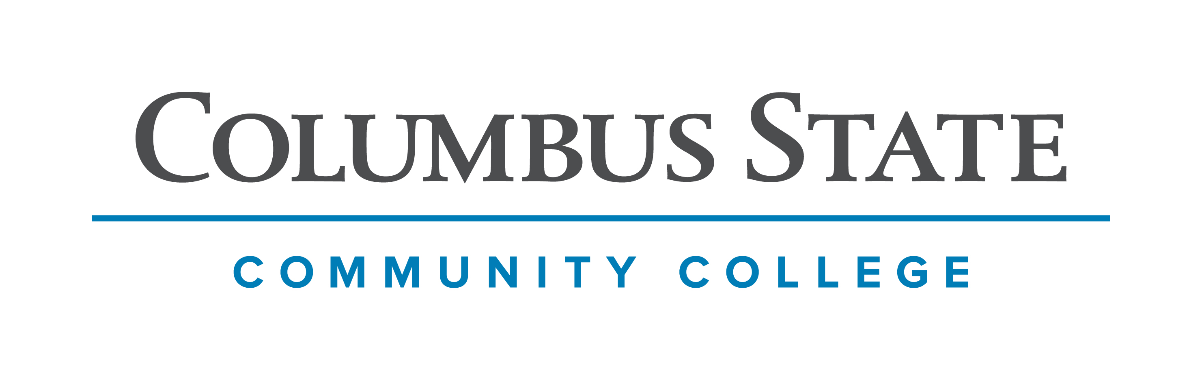
Columbus State Community College & West Virginia University
Associate of Arts leading to
Bachelor of Arts in Anthropology (WVU-BA)
Suggested Plan of Study
Columbus State Community College | Hours | WVU Equivalents | Hours
Year One, 1st Semester
ENGL 1100 or ENGL 1101 | 3 | ENGL 101 | 3
MATH 1148 | 4 | MATH 126 | 4
SOC 1101 | 3 | SOCA 101 | 3
*Visual/Performing Arts | 3 | *Visual/Performing Arts | 3
Social & Behavioral Science Elective | 3 | Social & Behavioral Science Elective | 3
COLS 1100 OR 1101 | 1 | ORIN 1TC | 1
TOTAL | 17 |  | 17
Year One, 2nd Semester
ENGL 2367 | 3 | ENGL 102 | 3
STAT 1350 | 3 | STAT 211 | 3
Approved AA Science Elective | 3 | Approved AS Science Elective | 3
*Historical Study | 3 | *Historical Study | 3
Approved AA Science Elective | 3 | Approved AS Science Elective | 3
TOTAL | 15 |  | 15
Year Two, 1st Semester
*Natural Science with Lab | 4 | *Natural Science with Lab | 4
ANTH 2200 or 2202 | 3 | SOCA 252 or 254 | 3
Approved AA Elective | 6 | Approved AA Elective | 6
ASC 1190 | 1 | PHIL 1TC | 1
TOTAL | 14 |  | 14
Year Two, 2nd Semester
*Natural Science (No Lab) | 3 | *Natural Science (No Lab) | 3
ANTH 2200 or 2202 | 3 | SOCA 252 or 254 | 3
*Historical Study | 3 | *Historical Study | 3
*Visual/Performing Arts | 3 | *Visual/Performing Arts | 3
Approved AA Elective | 3 | Approved AA Elective | 3
TOTAL | 15 |  | 15
*Course options listed at: http://www.cscc.edu/academics/transfer/aa-requirements.shtml
WEST VIRGINIA UNIVERSITY
Year Three, 1st Semester |  | Year Three, 2nd Semester
SOCA 105 | 3 | SOCA 259 | 3
Subfield Enrichment Requirement (Linguistics) or General Elective | 3 | Anthropology Elective | 3
Foreign Language 101 | 3 | Upper-level Anthropology Course 1 | 3
General Elective | 6 | Foreign Language 102 | 3
 |  | General Elective | 3
TOTAL | 15 | TOTAL | 15
Year Four, 1st Semester |  | Year Four, 2nd Semester
SOCA 359 | 3 | SOCA 488 | 3
Upper-level Anthropology Course 2 | 3 | Upper-level Anthropology Course 3 | 3
Foreign Language 203 | 3 | Foreign Language 204 | 3
General Elective | 6 | General Elective | 4
TOTAL | 15 | TOTAL | 13

Students transferring to West Virginia University under this Articulation Agreement will be accepted into the Sociology/Anthropology program despite lacking the SOCA 105 requirement.

Students transferring to West Virginia University with an Associate of Arts or Associate of Science degree will have satisfied the General Education Foundation requirements at WVU.

**STAT 1350 (WVU STAT 211) will satisfy the Subfield Enrichment Requirement for Anthropology majors at WVU. Students desiring to take Linguistics rather than Statistics should take a General Elective at CSCC in lieu of STAT 1350.

Students completing degrees in WVU’s Eberly College of Arts and Sciences are encouraged to work with their advisors to integrate completion of an academic minor or minors into their programs of study, to the degree allowed within elective hours. WVU offers over 100 minors that complement major fields of study, build on students’ unique interests, expand perspectives, and broaden skills. See http://catalog.wvu.edu/undergraduate/minors/#minorsofferedtext for a list of available minors. Columbus State students may begin completion of certain minors at CSCC by utilizing ELECTIVE hours to take courses equivalent to the minor’s introductory requirements at WVU.

Students who have questions regarding this articulation agreement or the transferability of coursework may contact the WVU Office of the University Registrar. All other questions should be directed to the WVU Office of Admissions.

The above transfer articulation of credit between West Virginia University and Columbus State Community College, is approved by the Dean, or the Dean’s designee, and effective the date of the signature.

_______________________________ _____________________________ ______________
Print Name Signature Date

Valerie Lastinger Ph. D. Associate Dean of Academic Affairs, WVU Eberly College of Arts and Sciences

