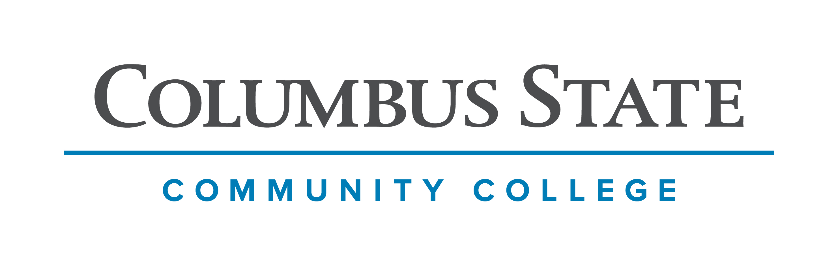
Columbus State Community College & West Virginia University
Associate of Science leading to
Bachelor of Science - Biology (WVU-BS)
Suggested Plan of Study
Columbus State Community College | Hours | WVU Equivalents | Hours
Year One, 1st Semester
ENGL 1100 or ENGL 1101 | 3 | ENGL 101 | 3
MATH 1151 | 5 | MATH 155 | 5
*Social & Behavioral Science | 3 | *Social & Behavioral Science | 3
*Historical Study | 3 | *Historical Study | 3
COLS 1100 or 1101 | 1 | ORIN 1TC | 1
TOTAL | 15 |  | 15
Year One, 2nd Semester
ENGL 2367 | 3 | ENGL 102 | 3
PHYS 1200 or PHYS 1250 | 5 | PHYS 101 or PHYS 111 | 5
STAT 2450 or STAT 2470 | 4 | STAT 211 or STAT 215 | 4
*Social & Behavioral Science | 3 | *Social & Behavioral Science | 3
ASC 1190 | 1 | PHIL 1TC | 1
TOTAL | 16 |  | 16
Year Two, 1st Semester
CHEM 1171 | 5 | CHEM 115 + CHEM 115L | 5
PHYS 1201 or PHYS 1251 | 5 | PHYS 102 or PHSY 112 | 5
BIO 1113 | 4 | BIOL 115 + BIOL 116 | 4
*A.S. Elective | 1 | *A.S. Elective | 1
TOTAL | 15 |  | 15
Year Two, 2nd Semester
CHEM 1172 | 5 | CHEM 116 + CHEM 116L | 5
BIO 1114 | 4 | BIOL 117 + BIOL 118 | 4
*A.S. Elective | 3 | *A.S. Elective | 3
*Visual/Performing Arts | 3 | *Visual/Performing Arts | 3
TOTAL | 15 |  | 15
*Course options listed at: http://www.cscc.edu/academics/transfer/aa-requirements.shtml

WEST VIRGINIA UNIVERSITY
Year Three, 1st Semester |  | Year Three, 2nd Semester
CHEM 233 & CHEM 235 | 4 | CHEM 234 & CHEM 236 | 4
BIOL 219 + 220 | 4 | BIOL 221 | 3
General Elective | 7 | BIOL 327 | 1
 |  | BIOL Elective Group 1 | 3
 |  | General Elective | 4
TOTAL | 15 | TOTAL | 15
Year Four, 1st Semester |  | Year Four, 2nd Semester
BIOL Elective Group 2 | 3 | BIOL Elective Group 4 | 3
BIOL Elective Group 3 | 3 | BIOL Elective Lab 2 | 4
BIOL Elective Lab 1 | 4 | BIOL Capstone | 2
General Elective | 6 | General Elective | 4
TOTAL | 16 | TOTAL | 13

Students must complete BIOL 1113, 1114 and CHEM 1171 with a C- or better to be admitted to the Biology program upon transferring to West Virginia University.

Students completing degrees in WVU’s Eberly College of Arts and Sciences are encouraged to work with their advisors to integrate completion of an academic minor or minors into their programs of study, to the degree allowed within elective hours. WVU offers over 100 minors that complement major fields of study, build on students’ unique interests, expand perspectives, and broaden skills. See http://catalog.wvu.edu/undergraduate/minors/#minorsofferedtext for a list of available minors. Columbus State students may begin completion of certain minors at CSCC by utilizing ELECTIVE hours to take courses equivalent to the minor’s introductory requirements at WVU.

Students transferring to West Virginia University with an Associate of Arts or Associate of Science degree will have satisfied the General Education Foundation requirements at WVU.

Students who have questions regarding this articulation agreement or the transferability of coursework may contact the WVU Office of the University Registrar. All other questions should be directed to the WVU Office of Admissions.

The above transfer articulation of credit between West Virginia University and Columbus State Community College, is approved by the Dean, or the Dean’s designee, and effective the date of the signature.

____________________________________ ____________________________________ _______________
Print Name Signature Date

Valerie Lastinger Ph.D. Associate Dean for WVU’s Eberly College of Arts & Sciences

