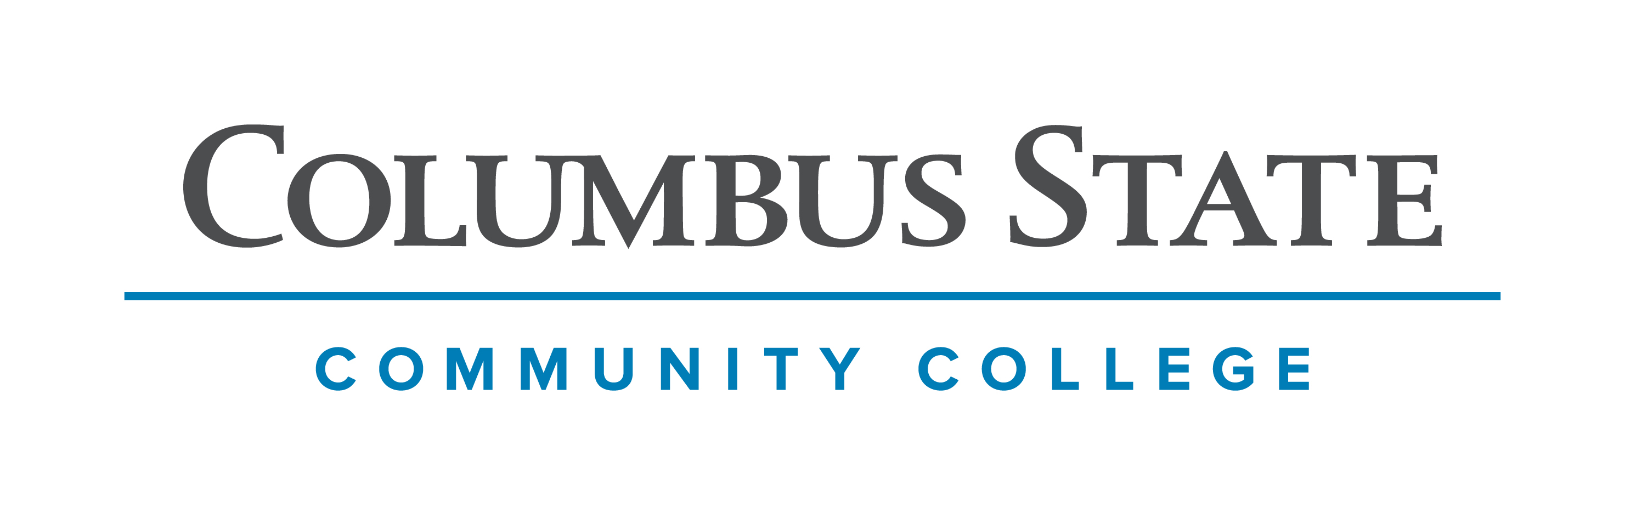
Columbus State Community College & West Virginia University
Associate of Science leading to
Bachelor of Art- Biology (WVU-BA)
Suggested Plan of Study
Columbus State Community College | Hours | WVU Equivalents | Hours
Year One, 1st Semester
ENGL 1100 or ENGL 1101 | 3 | ENGL 101 | 3
MATH 1131 | 6 | MATH 150 | 6
*Historical Study | 3 | *Historical Study | 3
*Visual/Performing Arts | 3 | *Visual/Performing Arts | 3
COLS 1100 or 1101 | 1 | ORIN 1TC | 1
TOTAL | 16 |  | 16
Year One, 2nd Semester
ENGL 2367 | 3 | ENGL 102 | 3
PHYS 1200 | 5 | PHYS 101 | 5
STAT 2450 | 4 | STAT 211 | 4
Social Science & Behavioral Science Elective | 3 | Social Science & Behavioral Science Elective | 3
TOTAL | 15 |  | 15
Year Two, 1st Semester
CHEM 1171 | 5 | CHEM 115 + CHEM 115L | 5
PHYS 1201 | 5 | PHYS 102 | 5
BIOL 1113 | 4 | BIOL 115 + BIOL 116 | 4
ASC 1190 | 1 | PHIL 1TC | 1
TOTAL | 15 |  | 15
Year Two, 2nd Semester
CHEM 1172 | 5 | CHEM 116 + CHEM 116L | 5
BIO 1114 | 4 | BIOL 117 + BIOL 118 | 4
Social & Behavioral Science Elective | 3 | Social & Behavioral Science Elective | 3
Approved AS Science Elective | 3 | Approved AS Science Elective | 3
TOTAL | 15 |  | 15

WEST VIRGINIA UNIVERSITY
Year Three, 1st Semester |  | Year Three, 2nd Semester
Foreign Language 101 | 3 | Foreign Language 102 | 3
BIOL 219 + BIOL 220 | 4 | BIOL 221 | 3
CHEM 233 & CHEM 235 | 4 | BIOL Capstone | 2
General Elective | 4 | BIOL 327 | 1
 |  | CHEM 234 & CHEM 236 | 4
 |  | General Elective | 1
TOTAL | 15 | TOTAL | 14
Year Four, 1st Semester |  | Year Four, 2nd Semester
Foreign Language 203 | 3 | Foreign Language 204 | 3
BIOL Elective | 4 | BIOL Elective Lab | 4
BIOL Elective | 3 | BIOL Elective | 3
General Elective | 6 | General Elective | 4
TOTAL | 16 | TOTAL | 14

Students must have a C- or higher in BIO 101, BIO 102, and CHM 111 (BIOL 115, BIOL 117, and CHM 115) in order to be admitted directly into the Biology program upon transferring to West Virginia University.

Students completing degrees from the WVU Eberly College of Arts and Sciences are encouraged to work with their advisors to integrate completion of an academic minor or minors into their programs of study. WVU offers over 100 minors that complement major fields of study, build on students’ unique interests, expand perspectives, and broaden skills. See http://catalog.wvu.edu/undergraduate/minors/#minorsofferedtext for a list of available minors. Columbus State students may begin completion of certain minors at CSCC by utilizing elective hours to take courses equivalent to the minor’s introductory requirements at WVU.

Students transferring to West Virginia University with an Associate of Arts or Associate of Science degree will have satisfied the General Education Foundation requirements at WVU.

Students who have questions regarding this articulation agreement or the transferability of coursework may contact the WVU Office of the University Registrar. All other questions should be directed to the WVU Office of Admissions.

The above transfer articulation of credit between West Virginia University and Columbus State Community College, is approved by the Dean, or the Dean’s designee, and effective the date of the signature.

____________________________________ ____________________________________ _______________
Print Name Signature Date

Valerie Lastinger Ph.D. Associate Dean for WVU’s Eberly College of Arts & Sciences

