Columbus State Community College & West Virginia University
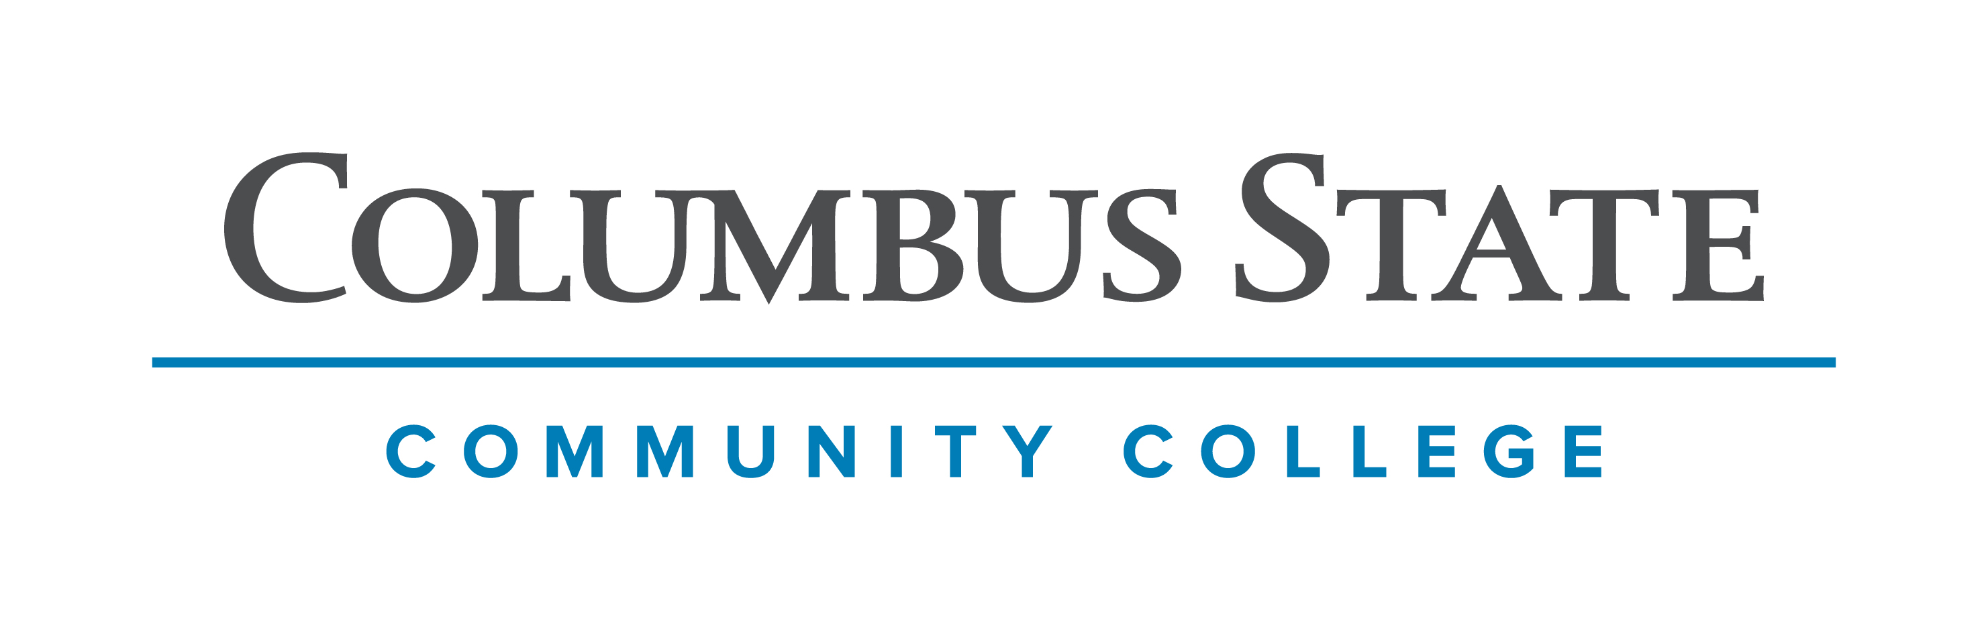
Associate of Science leading to
Bachelor of Science in Biochemistry (WVU-BS)
Suggested Plan of Study
Columbus State Community College | Hours | WVU Equivalents | Hours
Year One, 1st Semester
ENGL 1100 or ENGL 1101 | 3 | ENGL 101 | 3
MATH 1151 | 5 | MATH 155 | 5
CHEM 1171 | 5 | CHEM 115 + CHEM 115L | 5
*Social & Behavioral Science Elective | 3 | *Social & Behavioral Science Elective | 3
COLS 1100 OR 1101 | 1 | ORIN 1TC | 1
TOTAL | 17 |  | 17
Year One, 2nd Semester
ENGL 2367 | 3 | ENGL 102 | 3
MATH 1152 | 5 | MATH 156 | 5
CHEM 1172 | 5 | CHEM 116 + CHEM 116L | 5
*Historical Study Elective | 3 | *Historical Study Elective | 3
TOTAL | 16 |  | 16
Year Two, 1st Semester
CHEM 2251 | 5 | CHEM 233 | 5
CHEM 2254 | 3 | CHEM 235 | 3
BIOL 1113 | 4 | BIOL 115 & 116 | 4
*Visual/Performing Arts Elective | 3 | *Visual/Performing Arts Elective | 3
TOTAL | 15 |  | 15
Year Two, 2nd Semester
CHEM 2252 | 5 | CHEM 234 | 5
CHEM 2255 | 3 | CHEM 236 | 3
BIO 1114 | 4 | BIOL 117 | 4
*Social & Behavioral Science Elective | 3 | *Social & Behavioral Science Elective | 3
TOTAL | 15 |  | 15

COLUMBUS STATE OR WEST VIRGINIA UNIVERSITY
Summer Session | **PHYS 1250 OR **PHYS 111 | 5/4

WEST VIRGINIA UNIVERSITY
American Chemical Society Track
Year Three, 1st Semester |  | Year Three, 2nd Semester
BIOL 219 | 4 | BIOL 310 | 3
PHYS 112 | 4 | CHEM 341 & CHEM 342 | 4
CHEM 215 | 4 | CHEM 462 & CHEM 464 | 4
AGBI 410 & AGBI 412 | 4 | STAT 211 | 3
TOTAL | 16 | TOTAL | 14
Year Four, 1st Semester |  | Year Four, 2nd Semester
CHEM 401 | 1 | CHEM 310 | 3
CHEM 422 | 3 | CHEM 403 | 1
CHEM 497 | 3 | Biochemistry Elective | 3
Biochemistry Elective | 3 | Biochemistry Elective | 3
Biochemistry Elective | 3
TOTAL | 13 | TOTAL | 10
American Society of Biochemistry and Molecular Biology Track
Year Three, 1st Semester |  | Year Three, 2nd Semester
AGBI 410 & AGBI 412 | 4 | PHYS 101 | 4
CHEM 215 | 4 | BIOL 310 | 3
BIOL 219 | 4 | CHEM 462 & CHEM 464 | 4
STAT 211 | 3 | Biochemistry Elective | 3
TOTAL | 15 | TOTAL | 14
Year Four, 1st Semester |  | Year Four, 2nd Semester
BIOL 423 | 3 | AGBI 401 | 1
Biochemistry Elective | 4 | CHEM 341 & 342 | 4
Biochemistry Elective | 3 | BIOL 313 or 410 | 3
PHYS 102 | 4 | Biochemistry Elective | 4
 |  | BIOCHEM Capstone | 3
TOTAL | 14 | TOTAL | 15
**Students who seek to pursue to the American Chemical Society track are required to take PHYS 111, or its equivalent through Columbus State, prior to the first fall semester at West Virginia University. This allows for students to maintain progression through Physical Chemistry courses, and their subsequent courses in their senior year. Those students seeking the American Society of Biochemistry and Molecular Biology track can forgo this requirement and take their Physics courses as listed in the spring of their 3rd year.

Students transferring to West Virginia University with an Associate of Arts or Associate of Science degree will have satisfied the General Education Foundation requirements at WVU.

Students who have questions regarding this articulation agreement or the transferability of coursework may contact the WVU Office of the University Registrar. All other questions should be directed to the WVU Office of Admissions.

The above transfer articulation of credit between West Virginia University and Columbus State Community College, is approved by the Dean, or the Dean’s designee, and effective the date of the signature.

_______________________________ _____________________________ ______________
Print Name Signature Date

J. Todd Petty Ph.D. Associate Dean for WVU’s Agriculture and Natural Resources

____________________________________ ____________________________________ _______________
Print Name Signature Date

Valerie Lastinger Ph. D. Associate Dean of Academic Affairs, WVU Eberly College of Arts & Sciences

