Banner 9 Faculty Module
Term Selection / CRN Selection – It is no longer need to select term or CRN before searching. To directly access grade information, you can click Grade Entry, then select Midterm or Final Grades, then use search to find specific CRN or search by Term. To find student information, you can directly access it via the student links explained below.
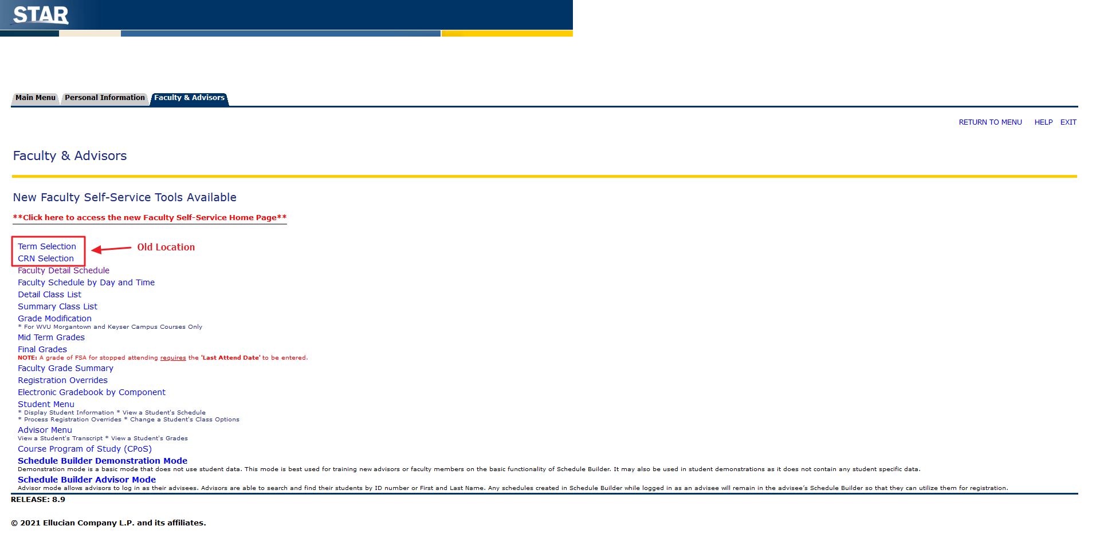
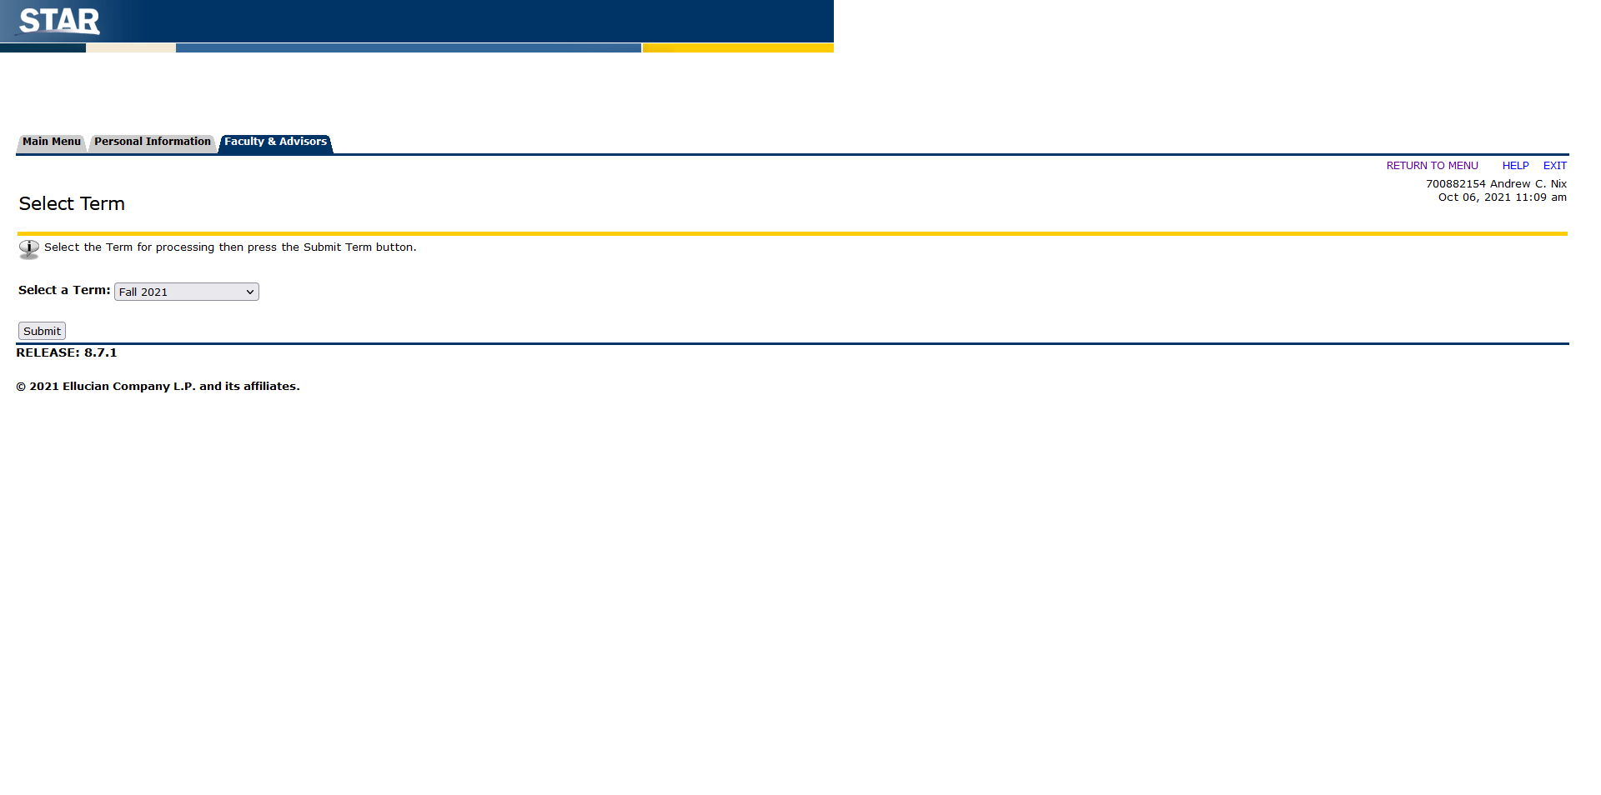
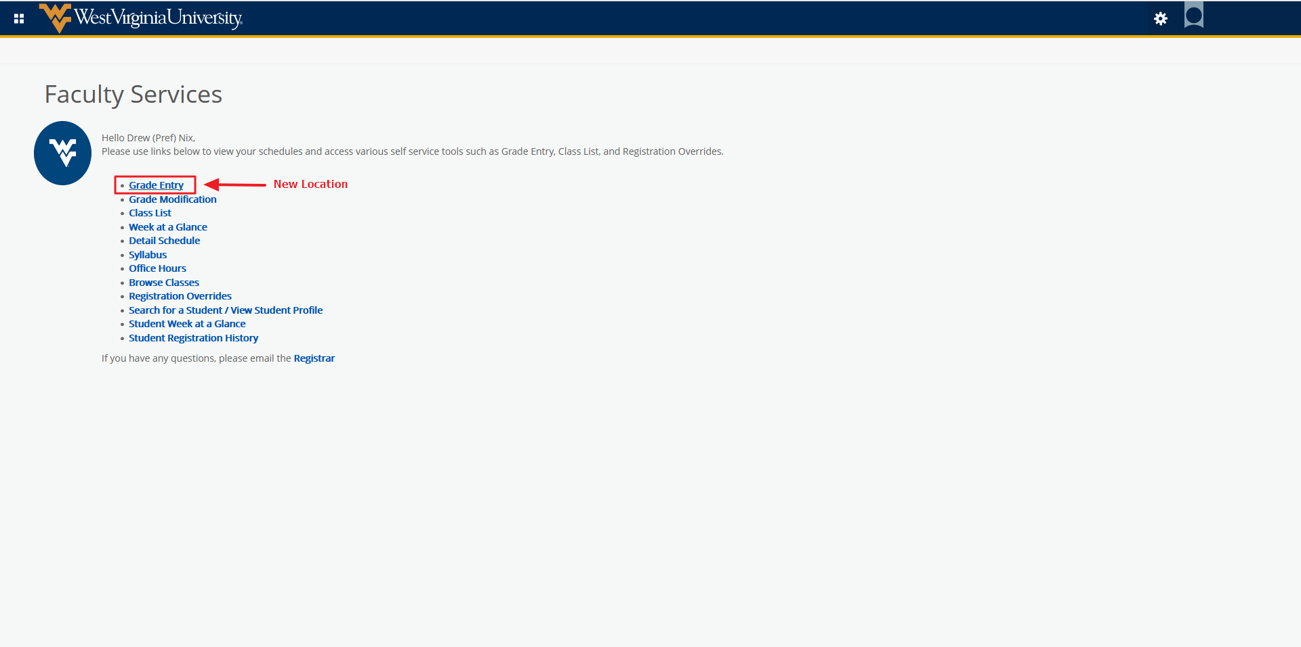
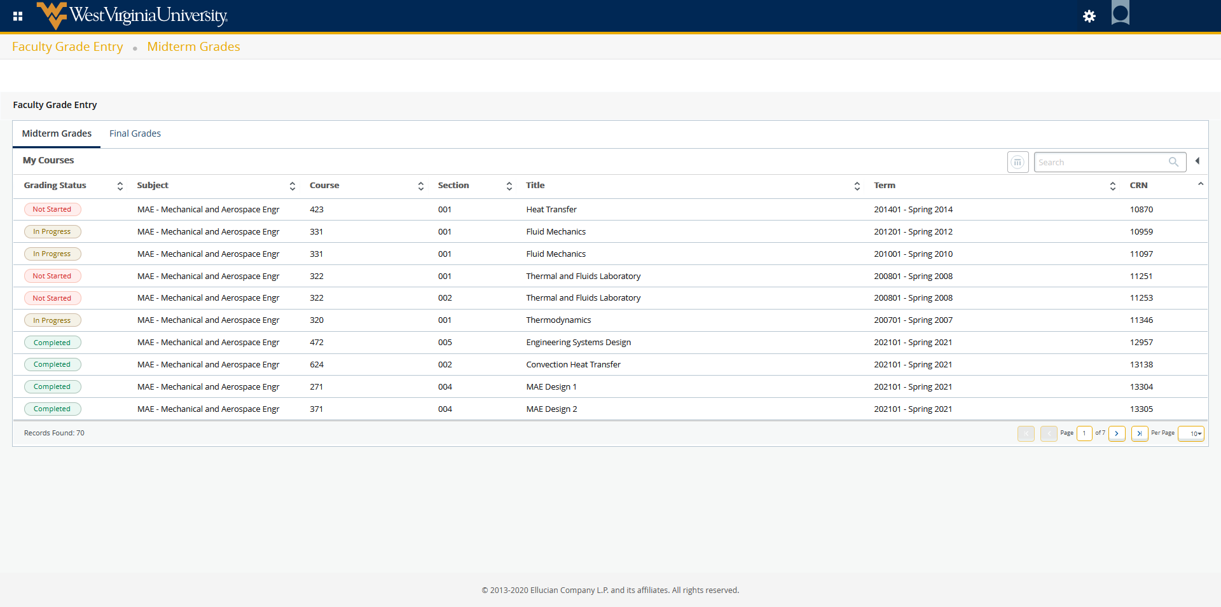
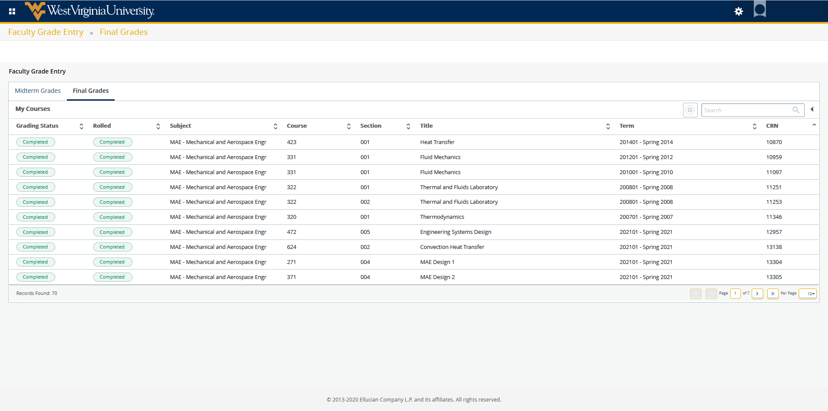
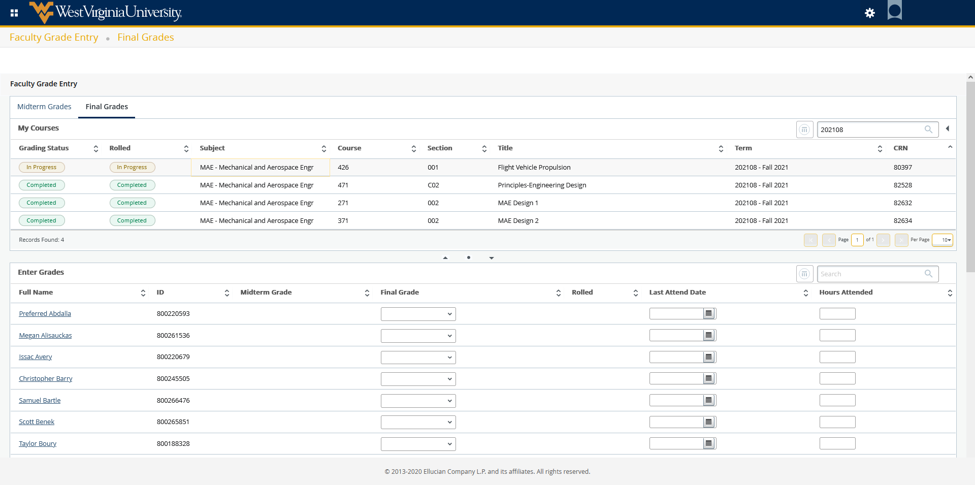
Mid Term Grades / Final Grades /Faculty Grade summary – These pages have been combined into “Grade Entry”. Important grade entry information is located in the sideways arrow next to the scroll bar. Both Midterm and Final grade entry occurs on this page. Please note which grade entry you are in before searching. You can search by Term, CRN, Title, Subject, or Course. Clicking the course opens it for grade entry. The list of students is displayed below the course listing. The options for grade entry are the same as before. Please ensure you are appropriately using the F, FNA, and FSA grades and their associated Last Attendance Date. This page now allows for more than 25 students to be displayed at once. You can also search for an individual student. Please note the timeout is still in effect so please save often. The reset button clears out any grades you have entered before saving. It will not clear out grades you have already saved.
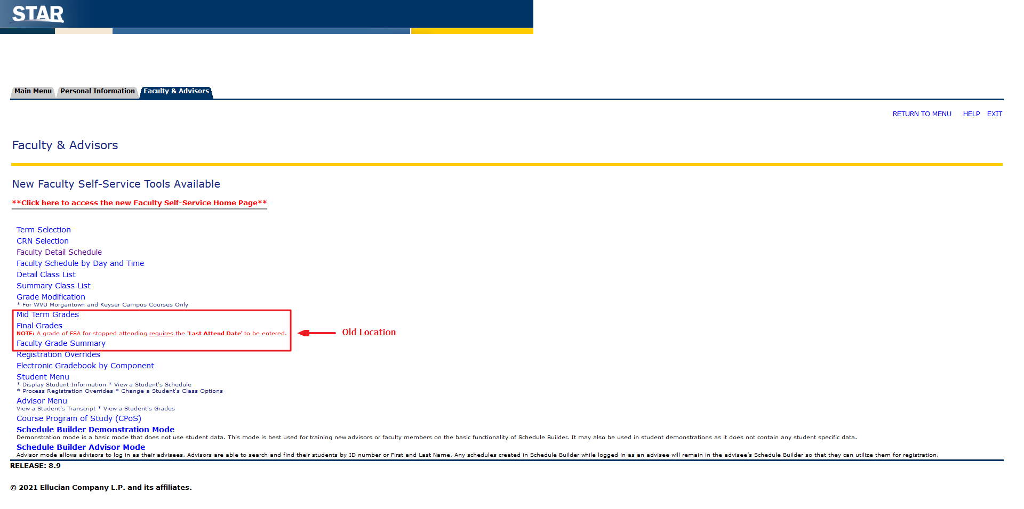
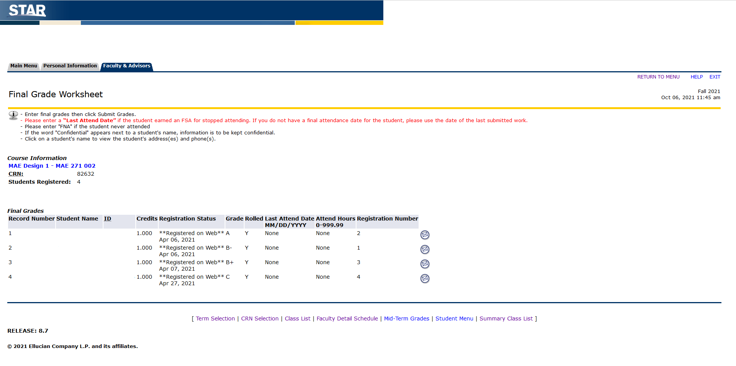
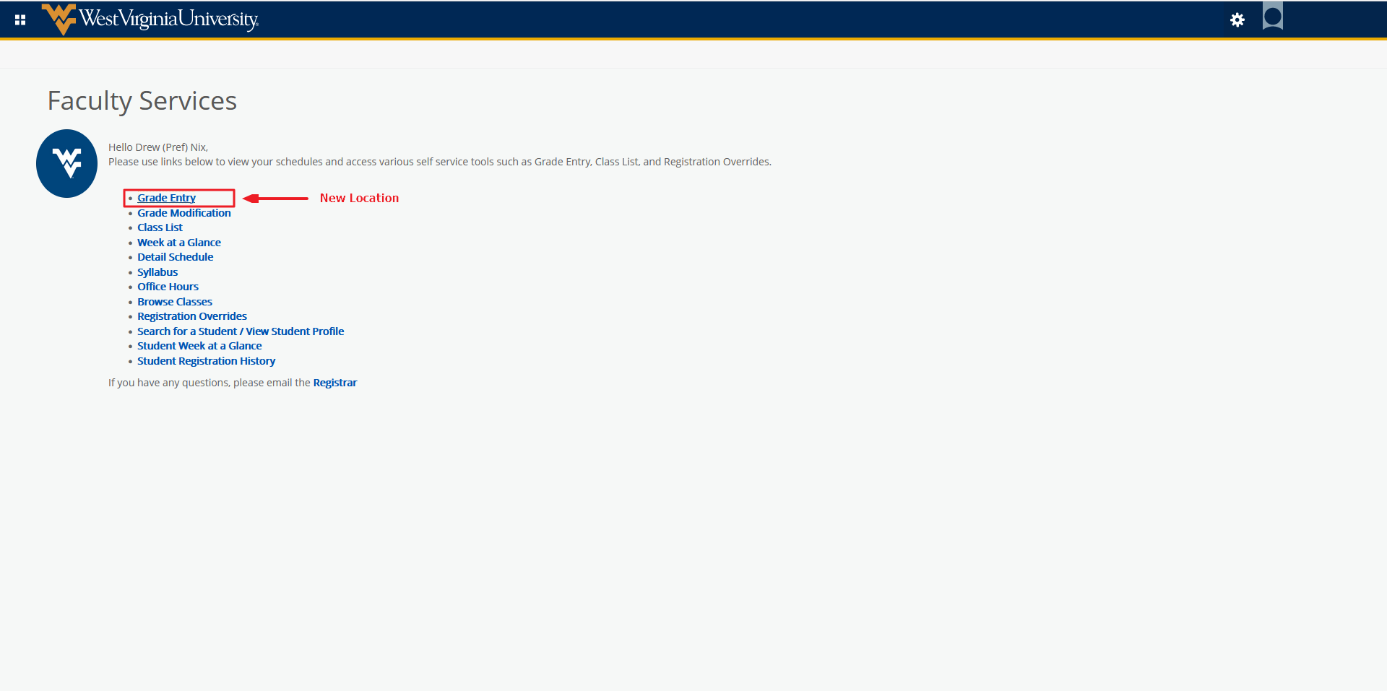
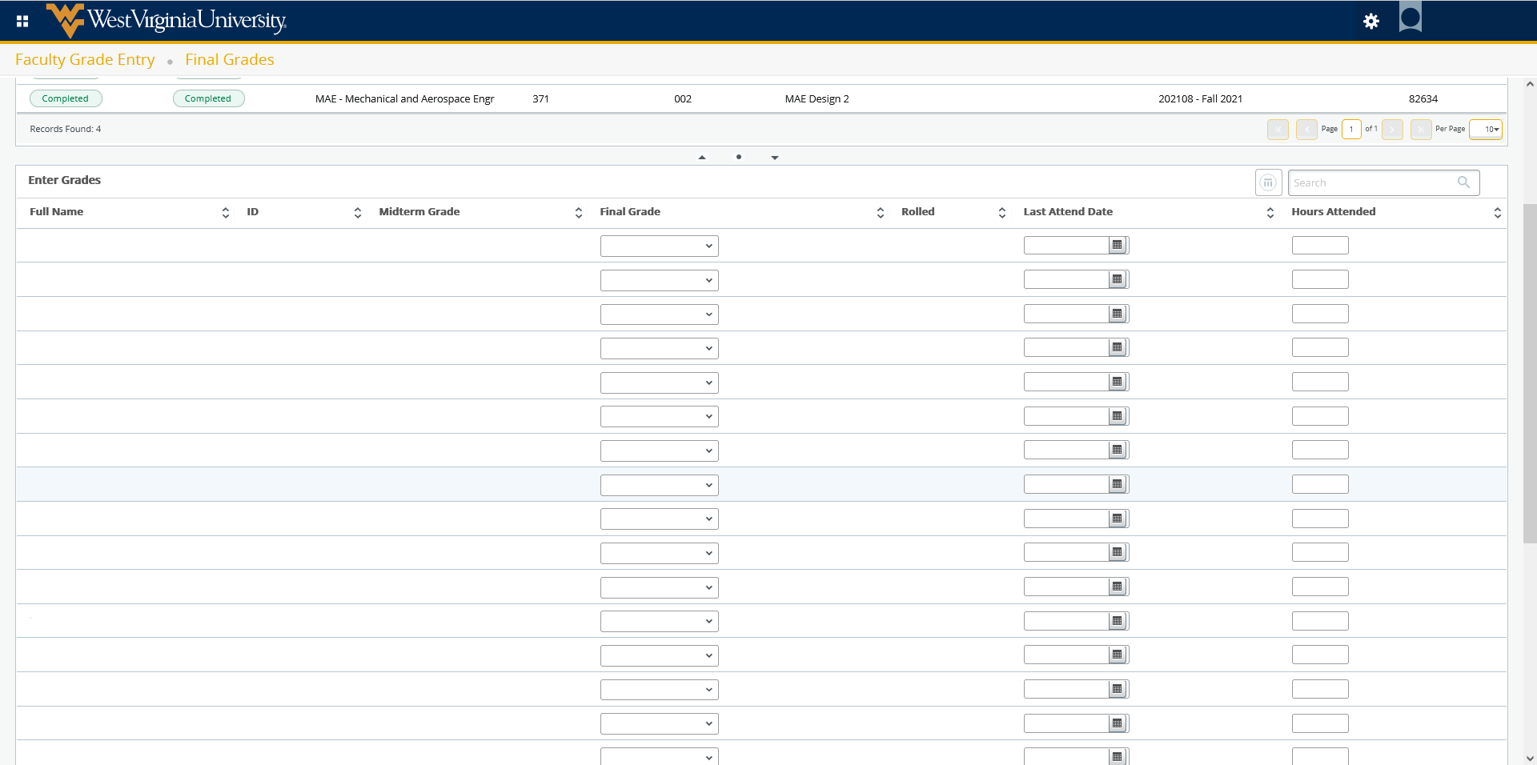
Faculty Detail Schedule – Now called Detail Schedule. On this page you will be able to search by Term and CRN. Term and CRN are both required. After searching you can click the CRN link for additional section information. Clicking course title will give additional course information. General course information, meeting day and times, enrollment counts, syllabus, and office hours are all available on this page. A link to the class roster is also available here.
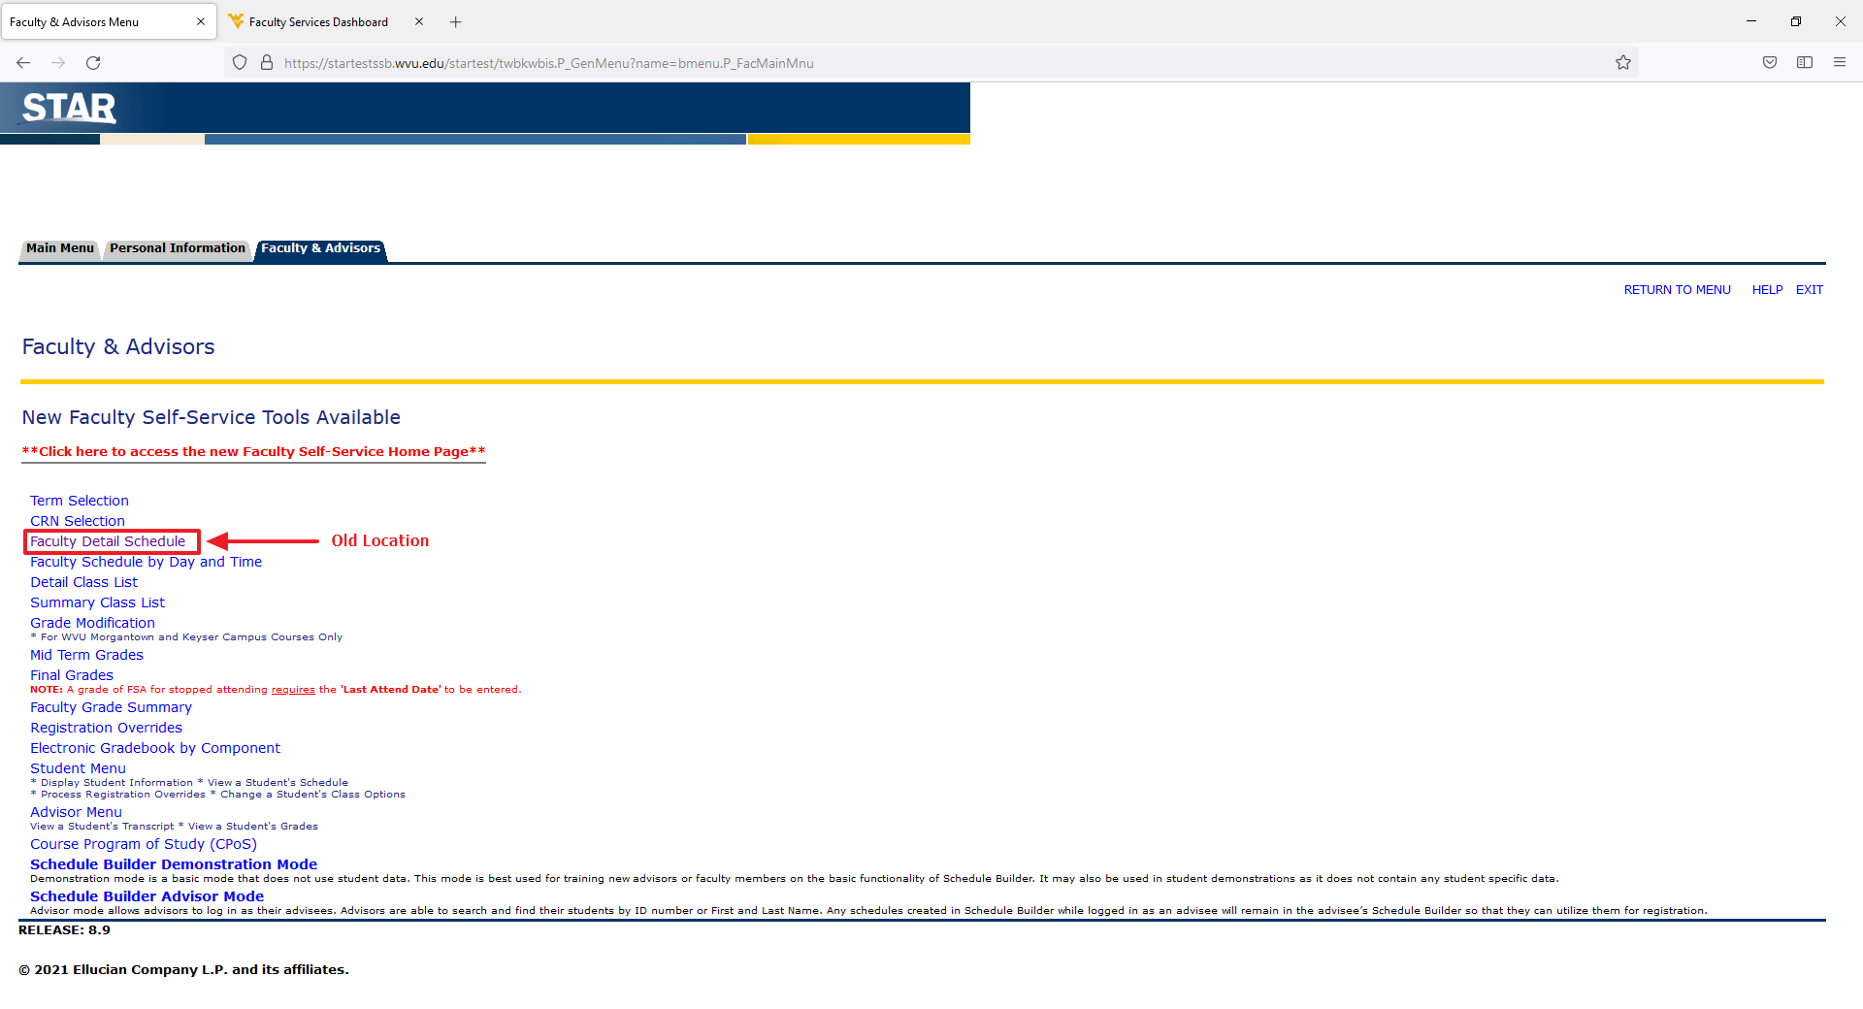
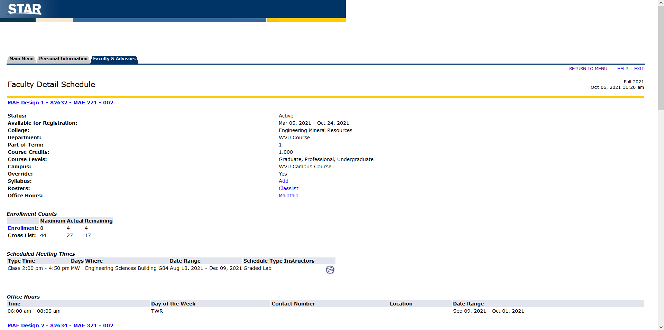
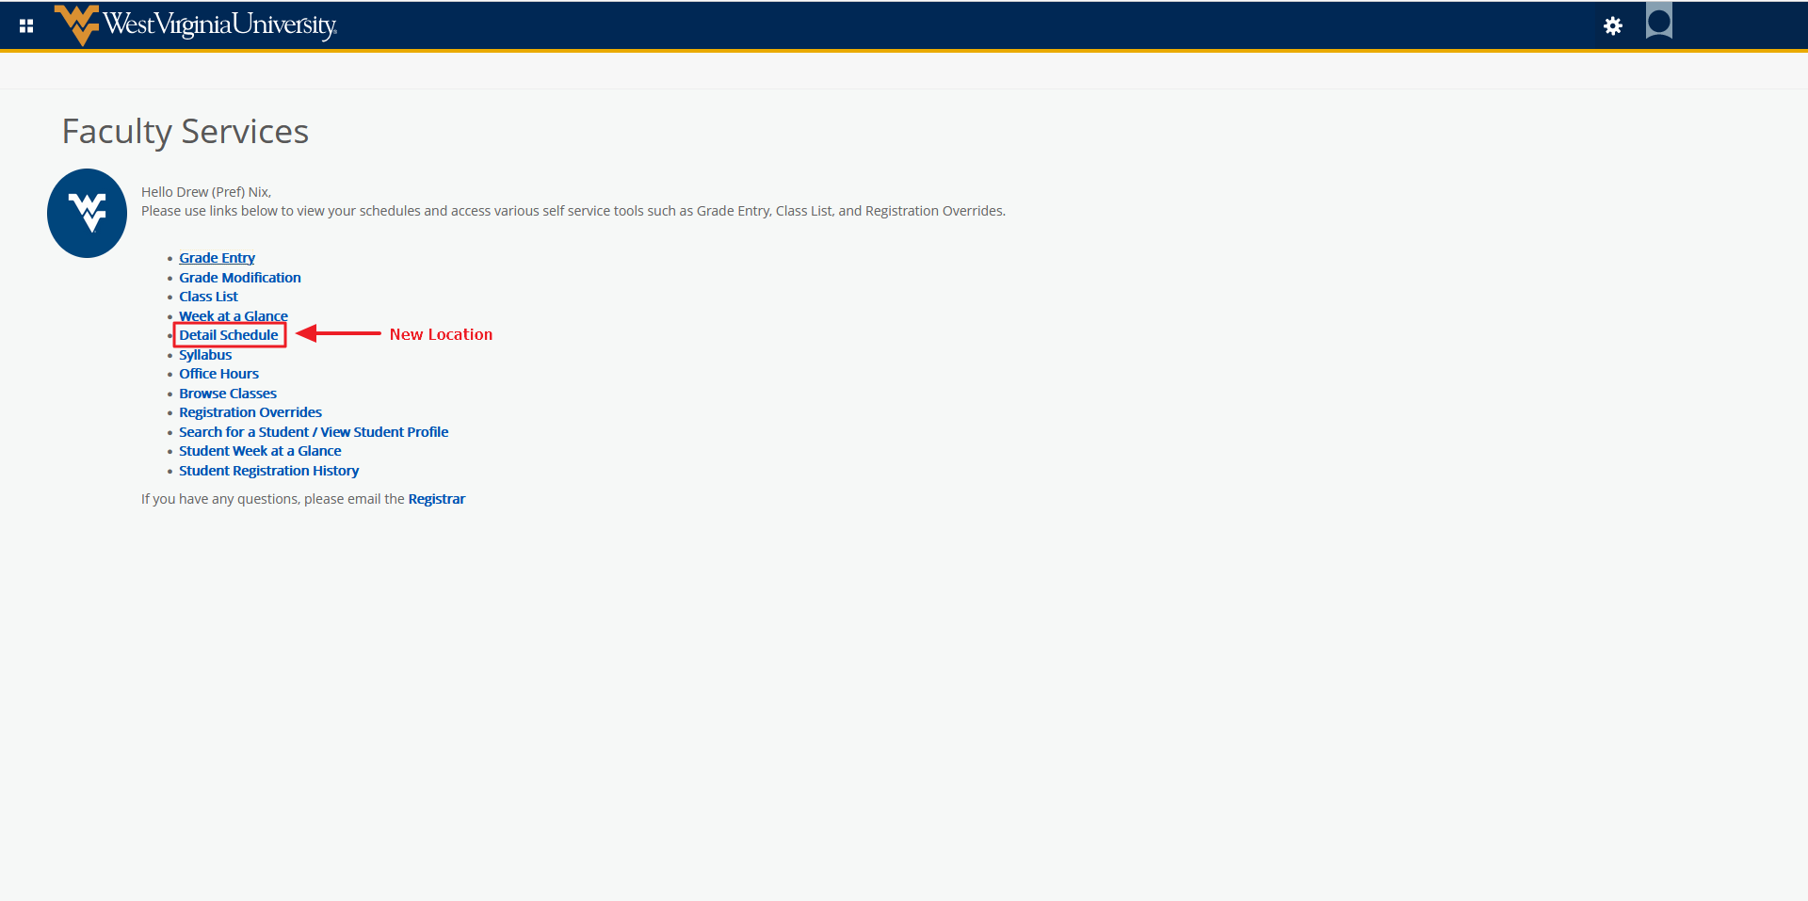
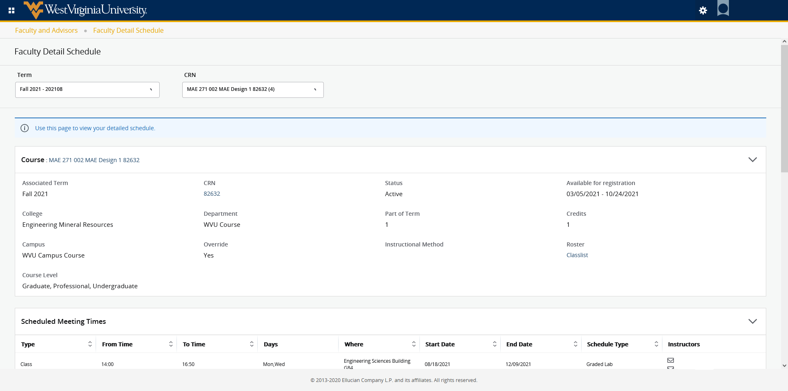
Faculty Schedule by Day and Time – This is now called “Week at a Glance”. This page will give you a weekly view of your assigned courses. You can search by a specific week or page through the weeks of the term. Clicking on a course will navigate you to the Detail Schedule. Courses without assigned times will be listed at the bottom of the calendar.
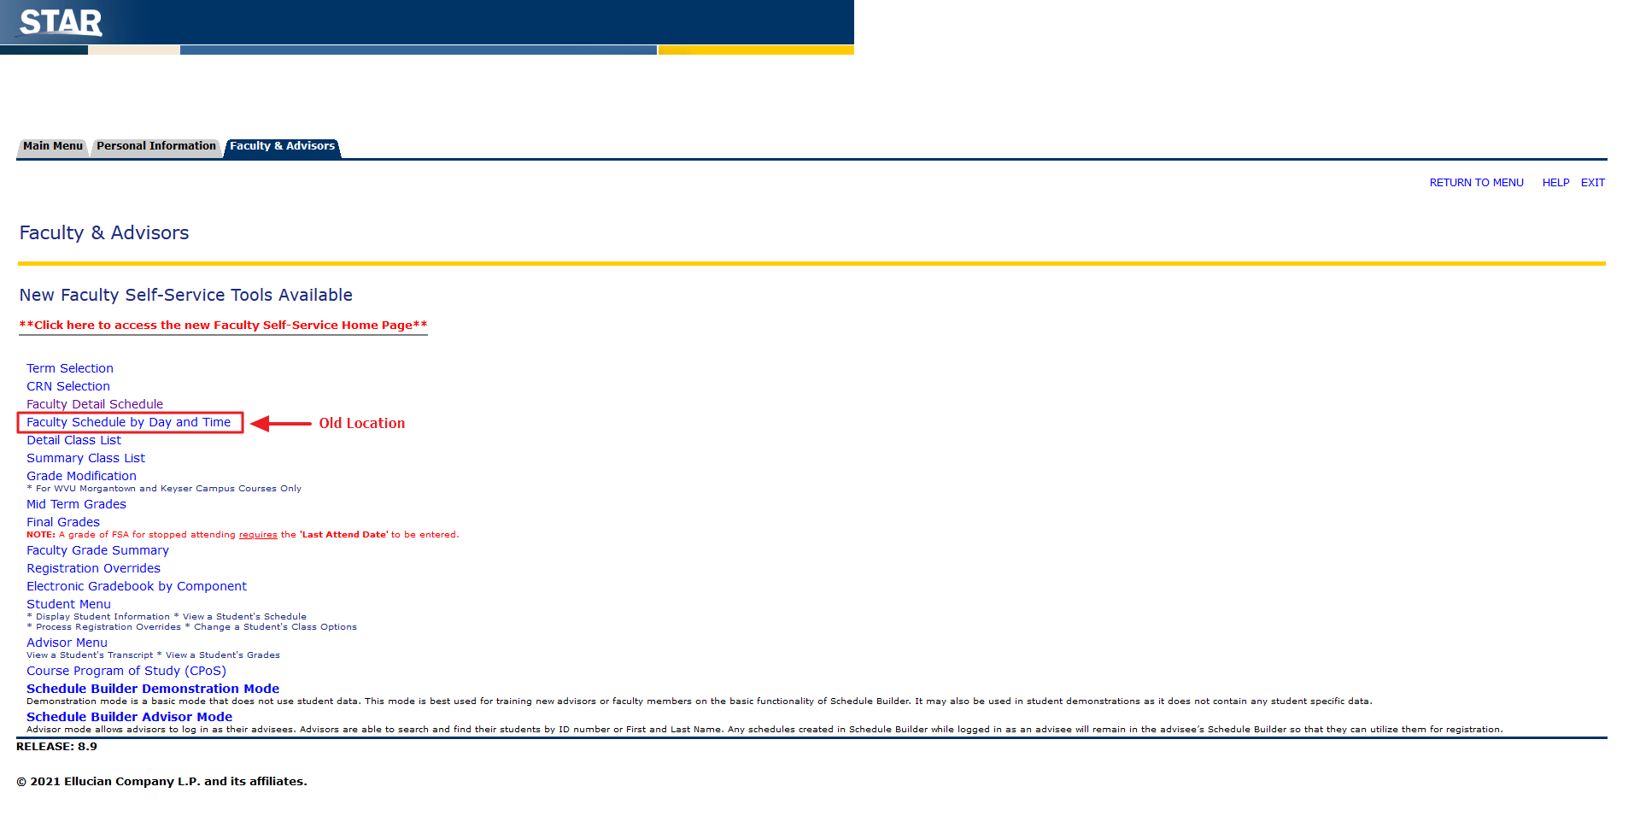
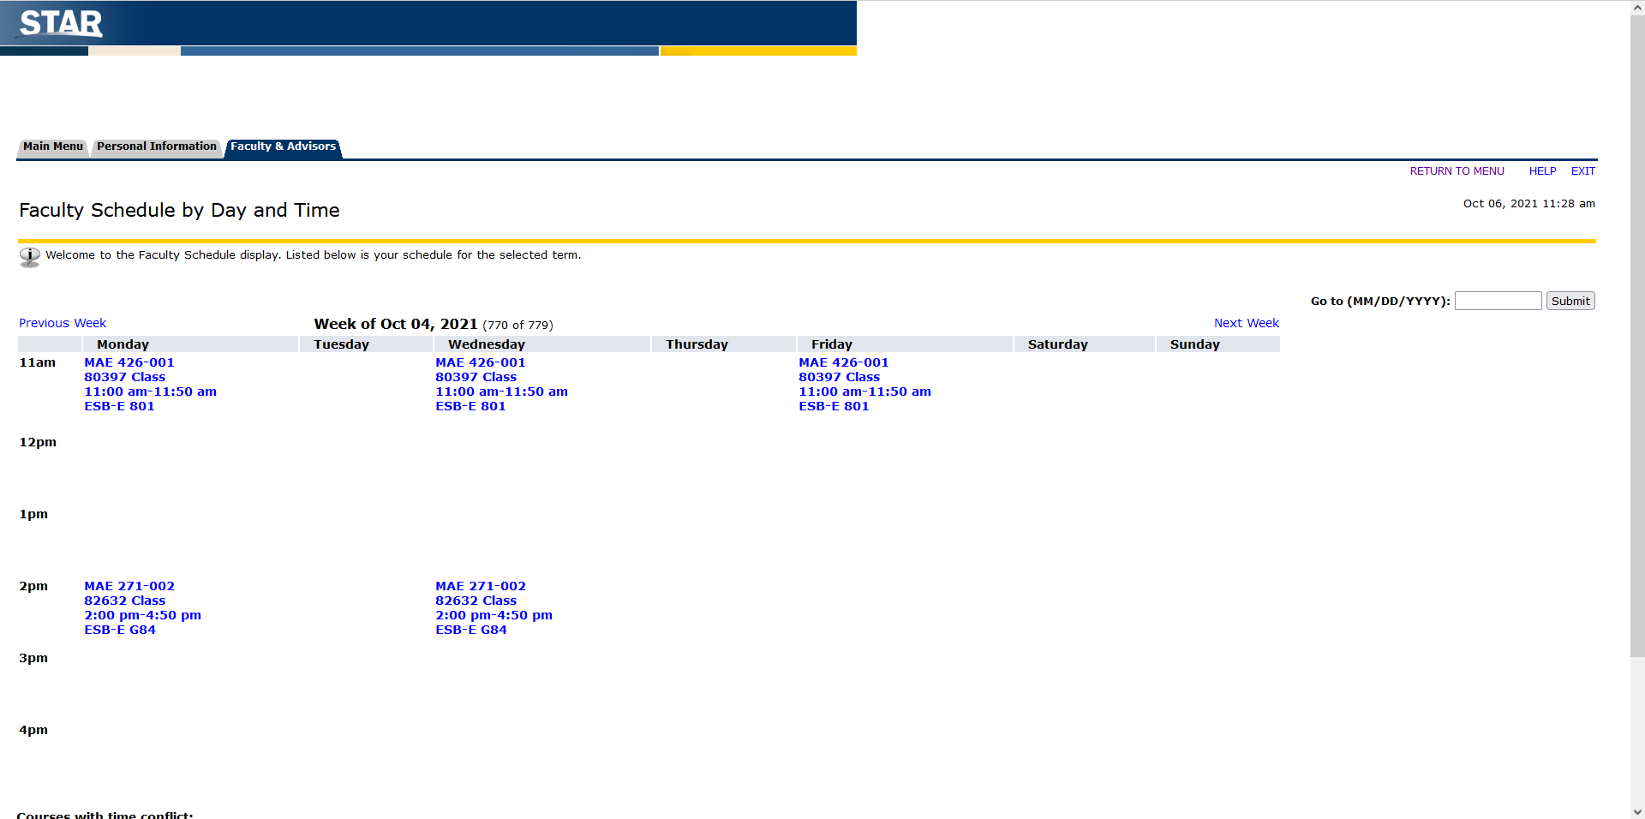
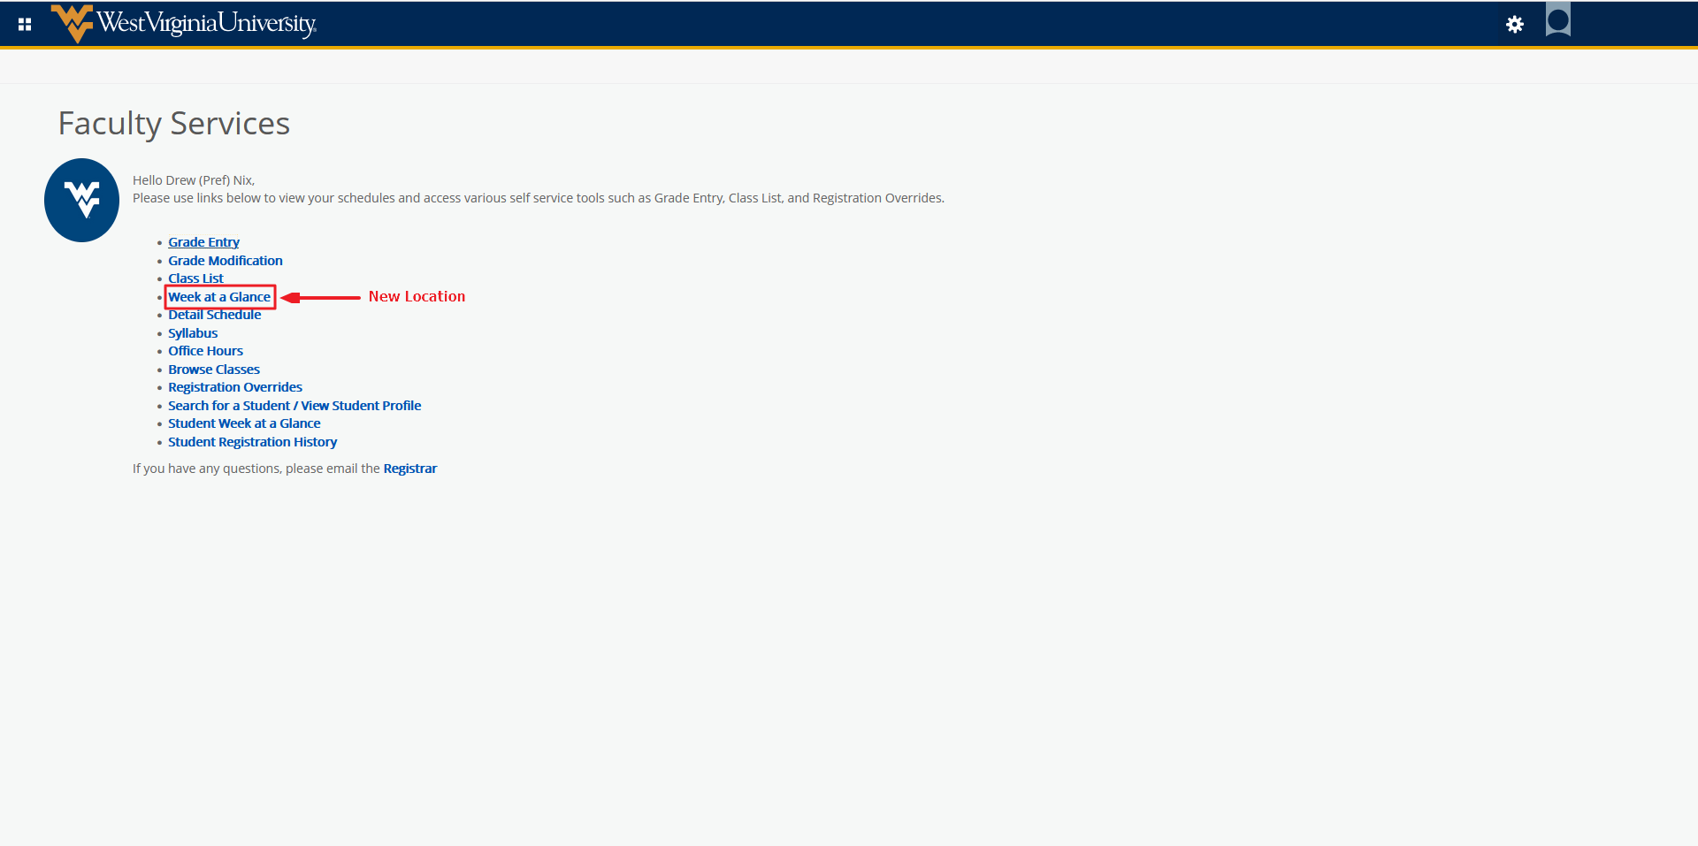
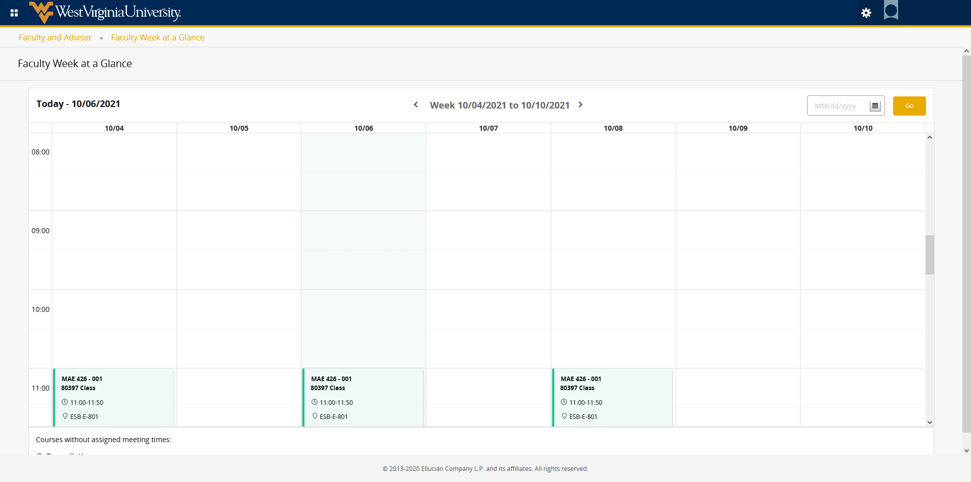
Detail Class List / Summary Class List – These two pages have been combined into “Class List”. After clicking “Class List” you can filter by term or view all terms. You can also search by Subject, Course Title, CRN, or Term. Clicking on a course in the list will open the Summary View of the Class List. If you need to see the detail view, click the dropdown next to Summary View. From either page, you can see enrollment counts, email all students, or select certain students to email, and access grades for students. Clicking on the Wait List tab will allow you to see students that are currently waitlisted for the section. Clicking the Export Button allows you to download a roster of the course. Clicking the Print button allows you to print the page with student detail information. From this page, if you would like to view another of your CRNs for the same term, click the dropdown next to the Course/CRN and select another. Clicking an individual student name opens the Student Profile for the selected student.
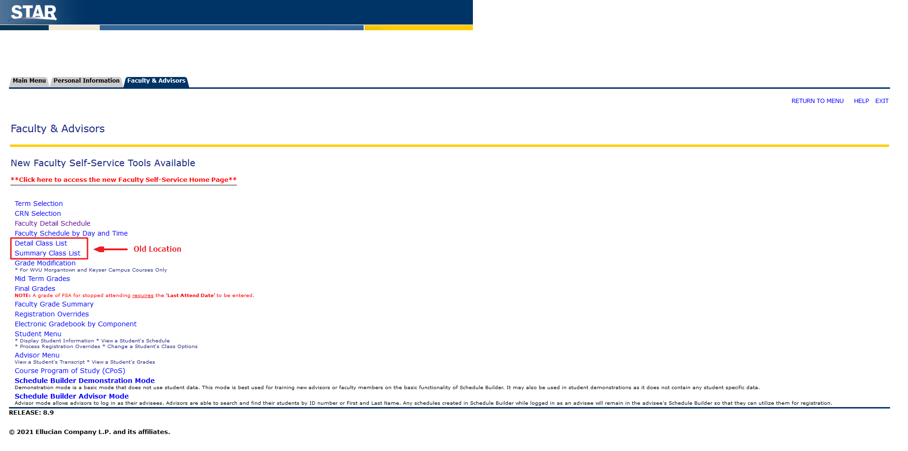
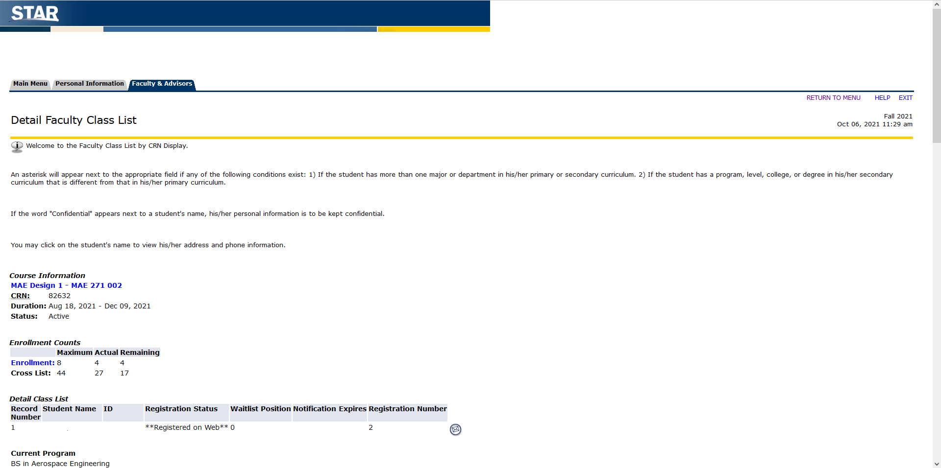
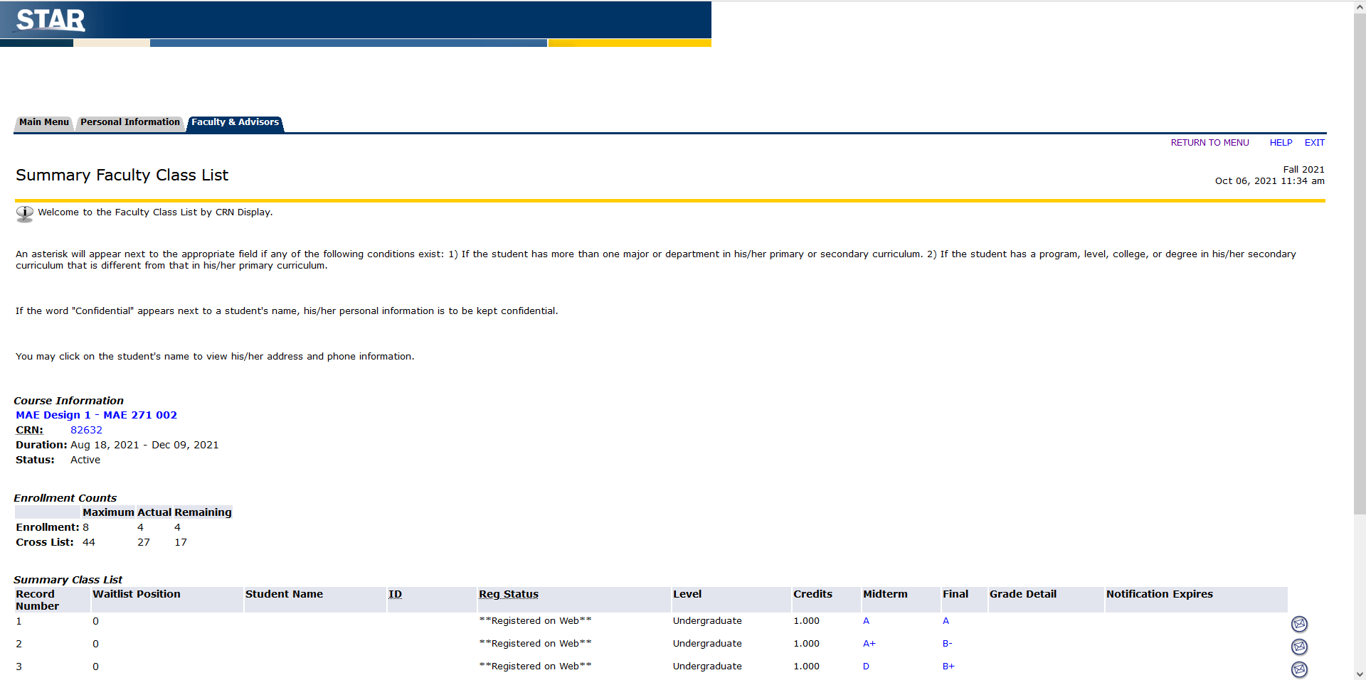
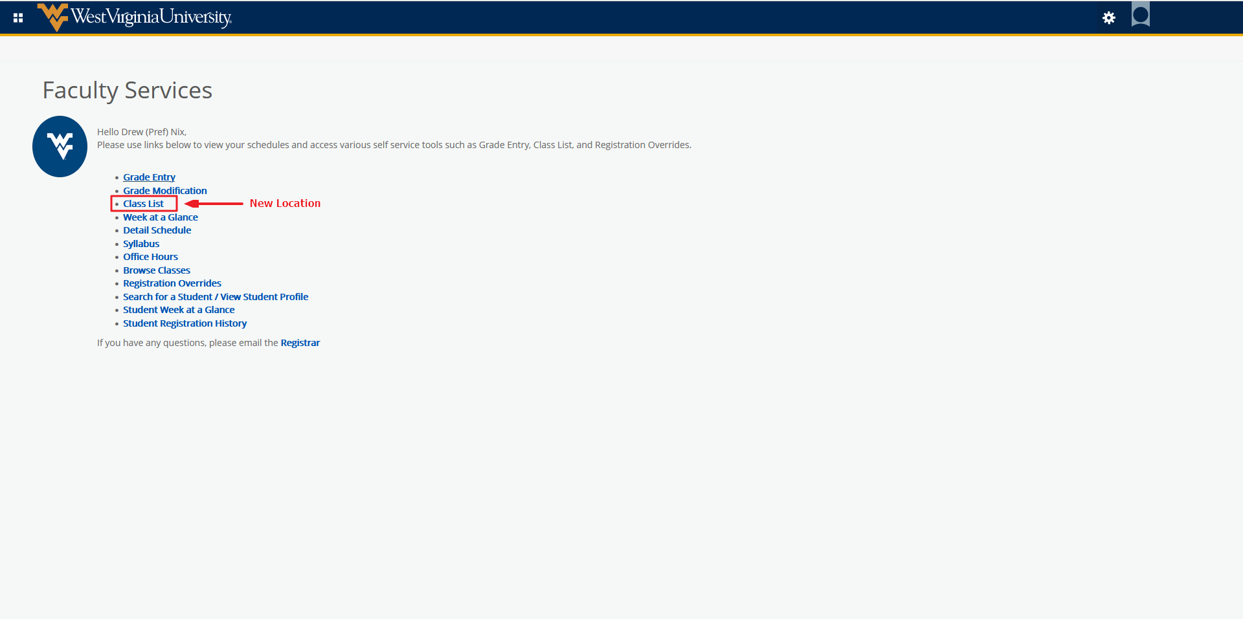
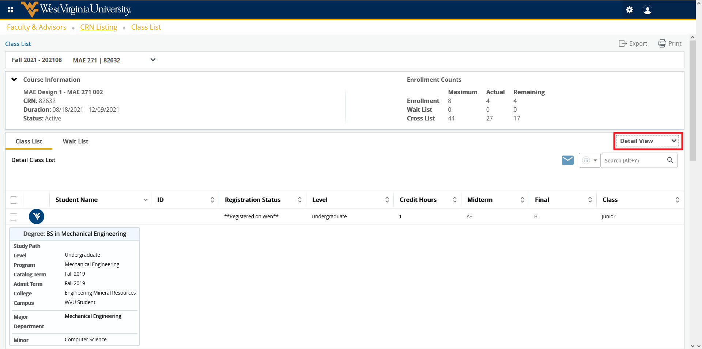
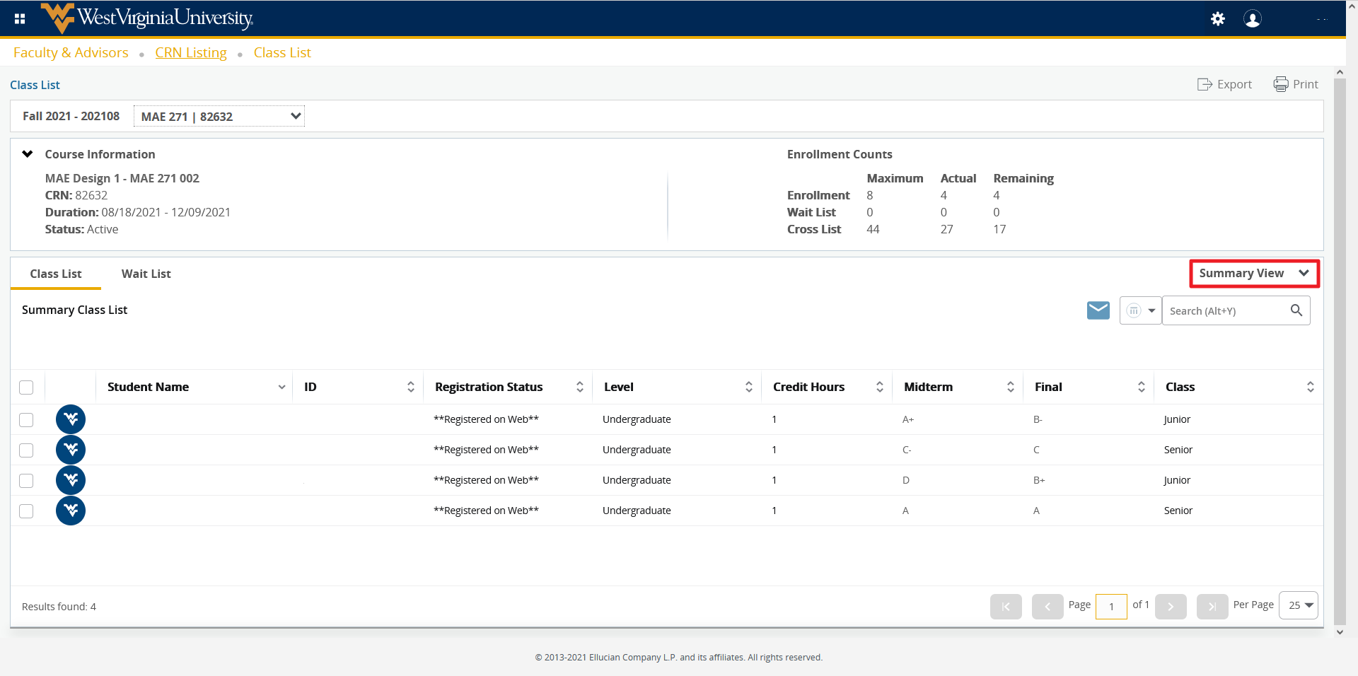

Grade Modification – There is a new tool being utilized for grade modifications. It works very similarly to the old grade modification with some improvements. Clicking Get Help will load additional instructions.
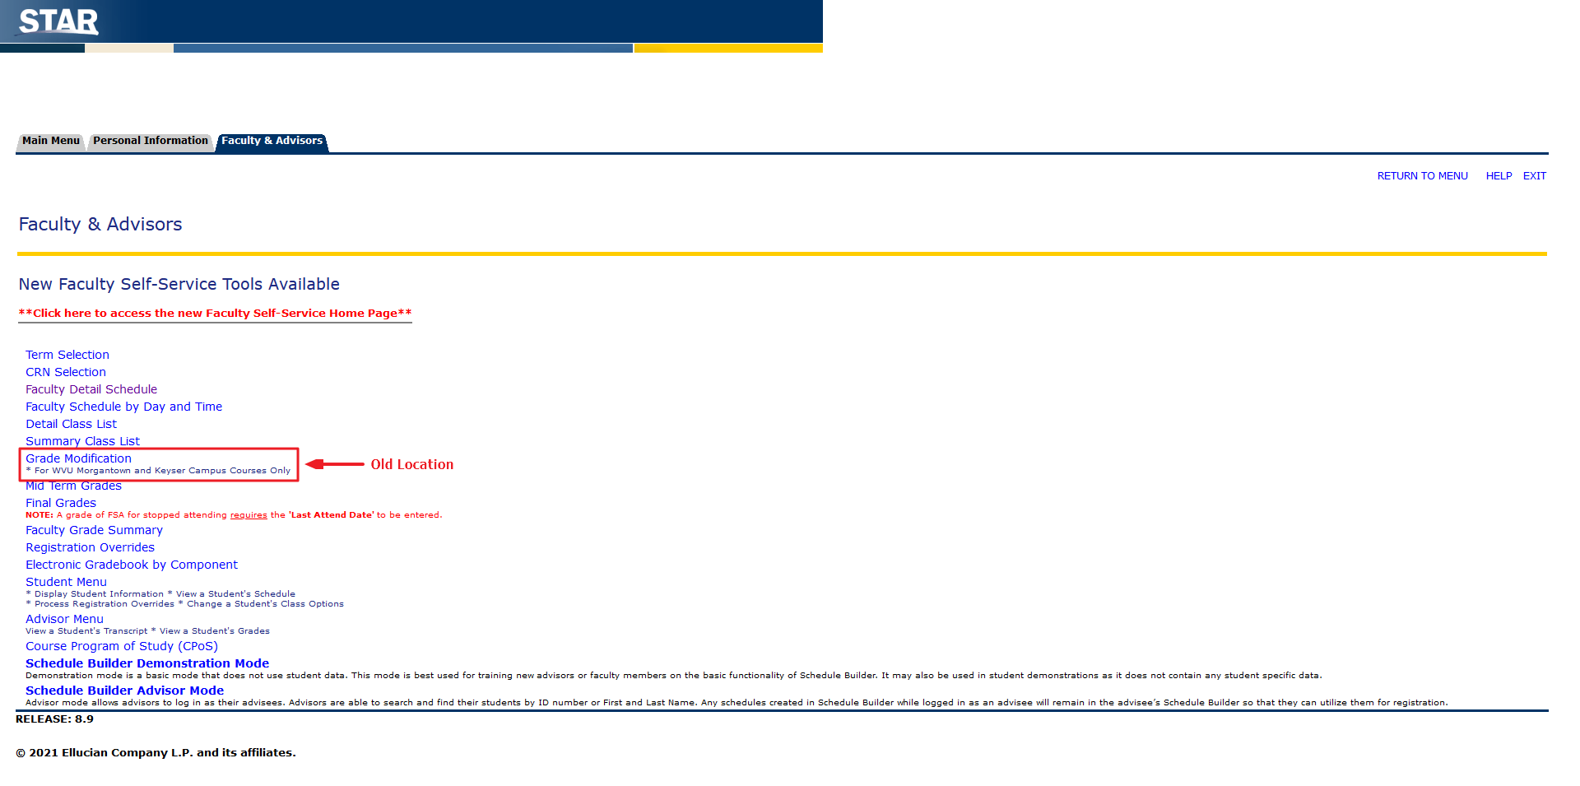
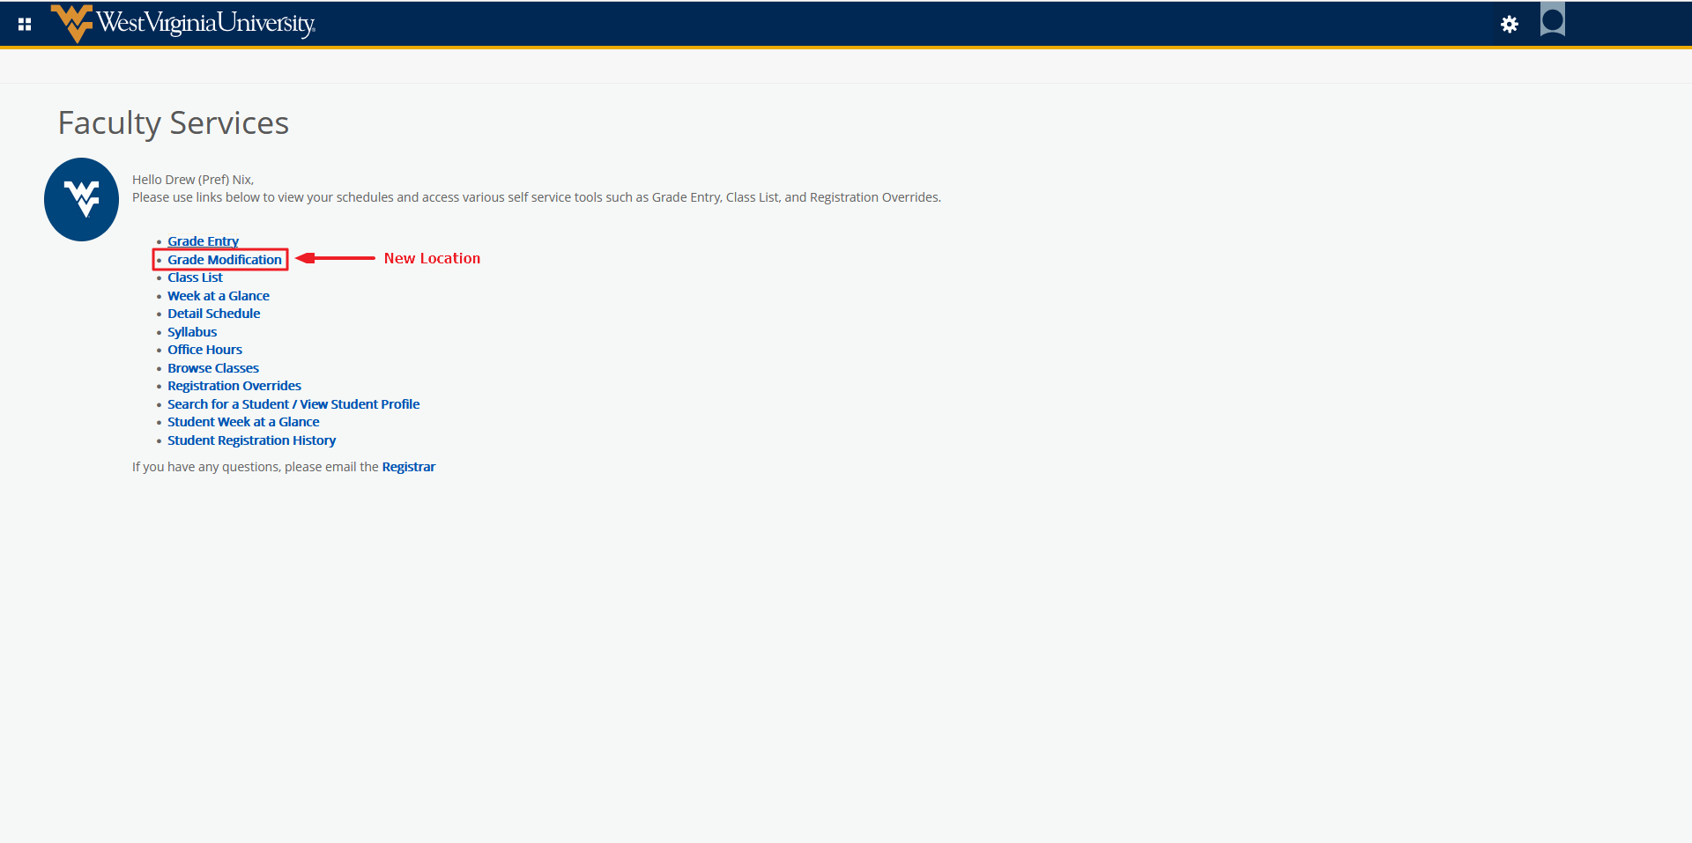
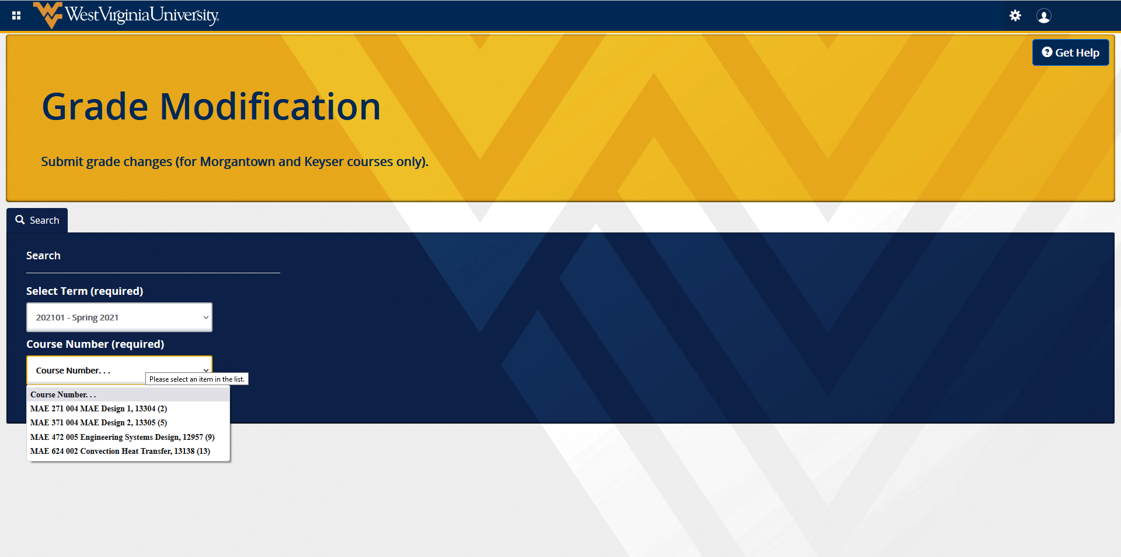
Registration Overrides – First select the term, then enter either the student ID or name. A term is required to search for a student. The most reliable search is by student ID. Searching by name returns any partial match, for instance “jack” will return “Jack, Jackson, etc”. Clicking submit will return the results of your search. Note: you do not need to change the search type from “All”. Click the student from the student list and it will open the override menu. This page gives the current registrations for the student and allows you to grant them an override into one of your assigned courses. Current overrides for the student will be listed above their registration information. If the student has no overrides, this information will be displayed at the bottom of the page. Entering overrides works very similarly as the current system, but you are now able to submit more than one at once, if necessary.
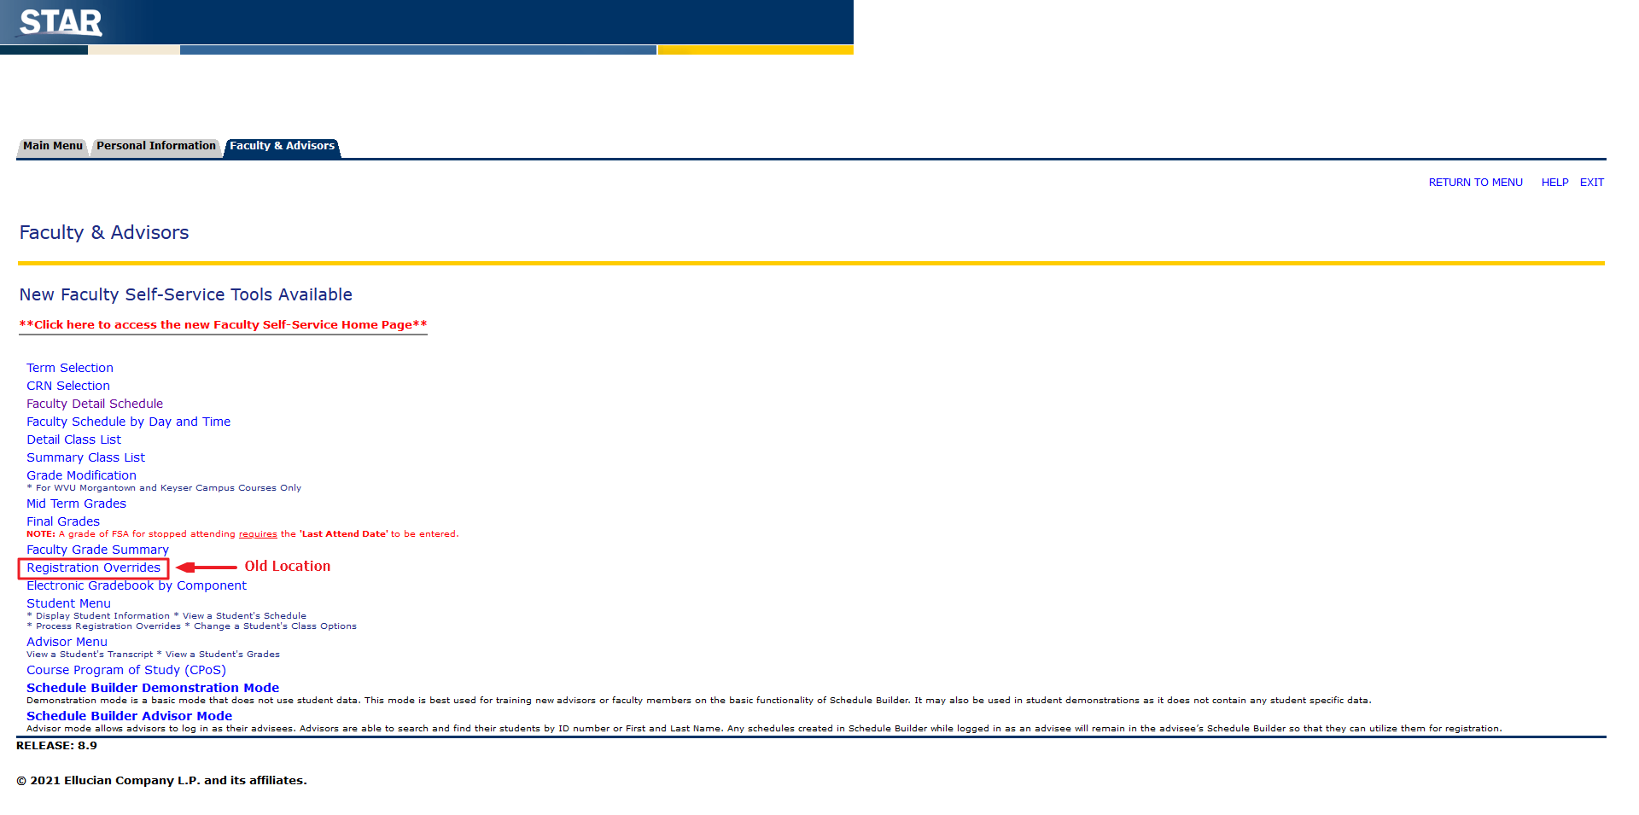
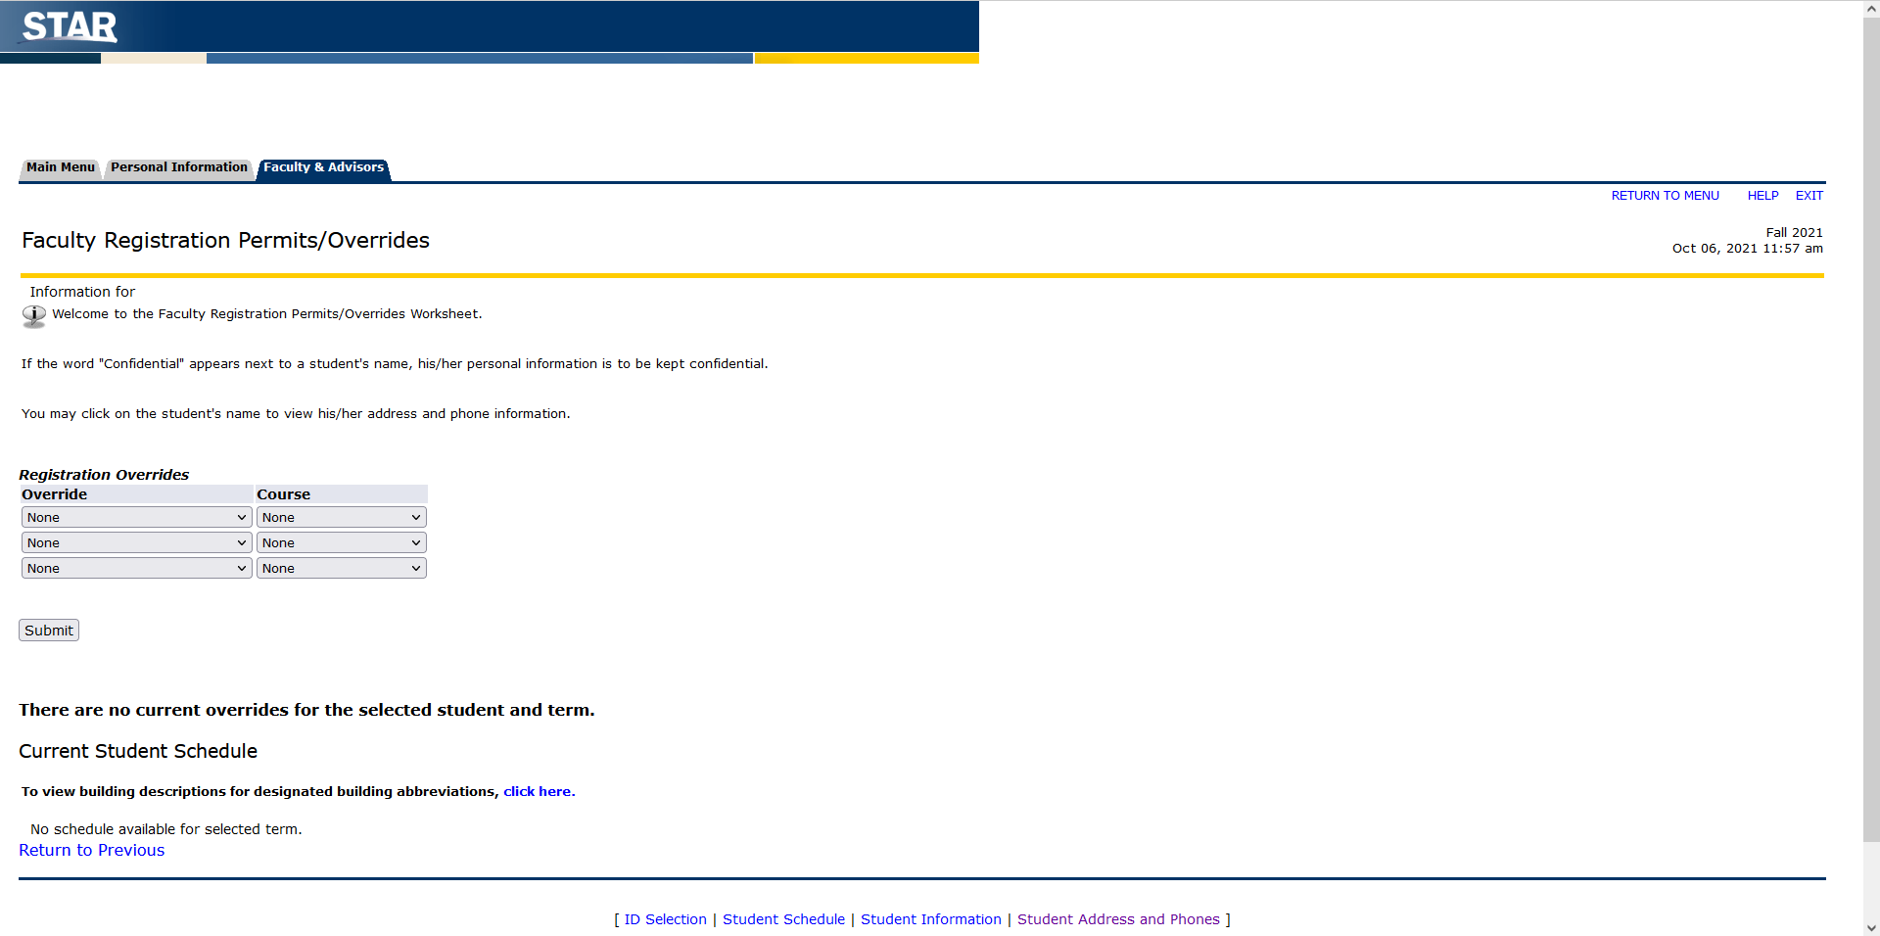
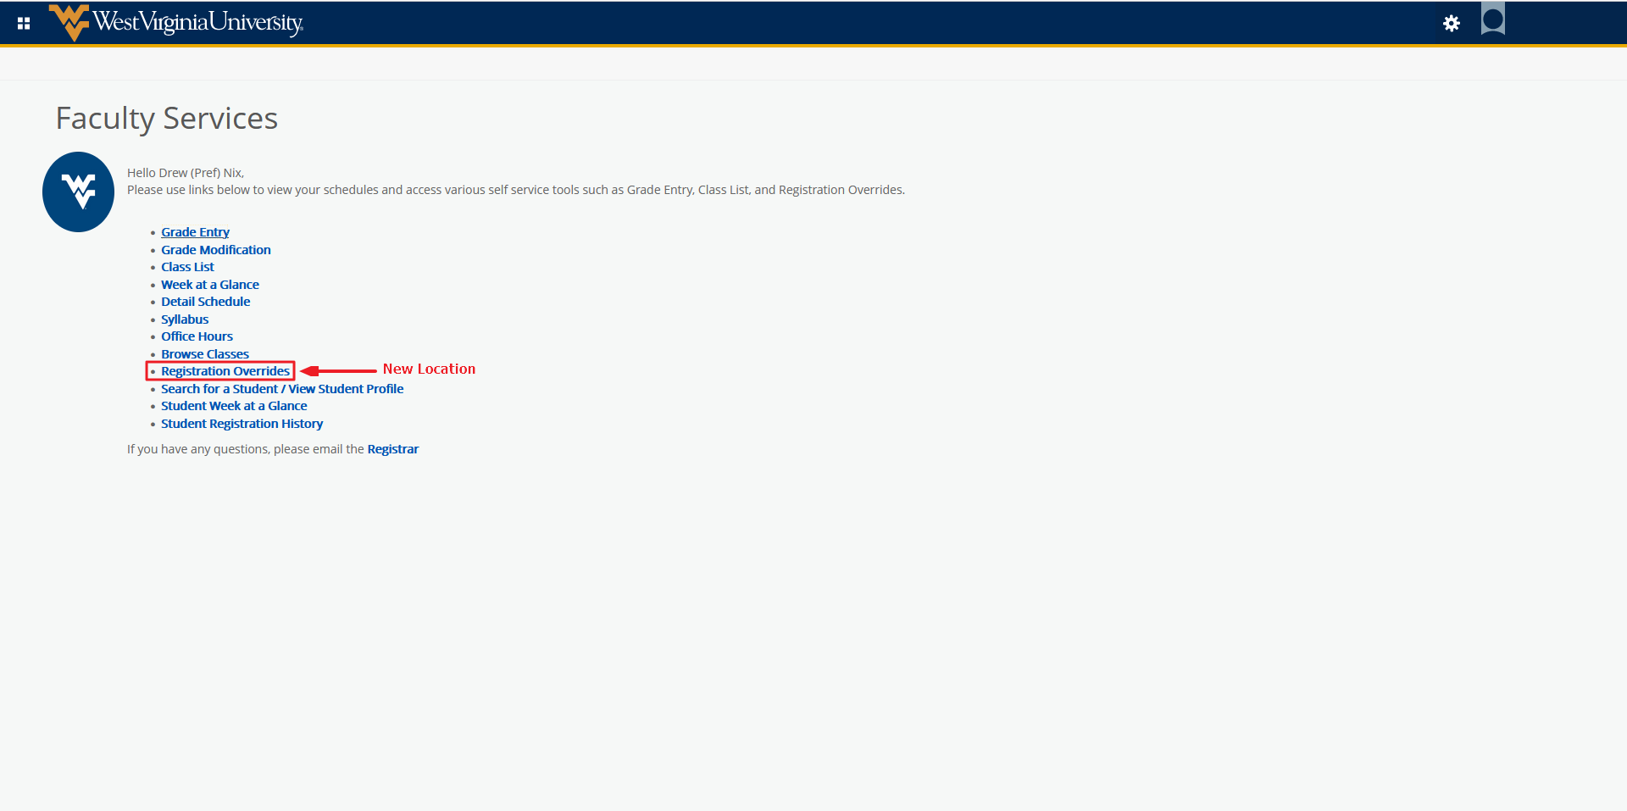
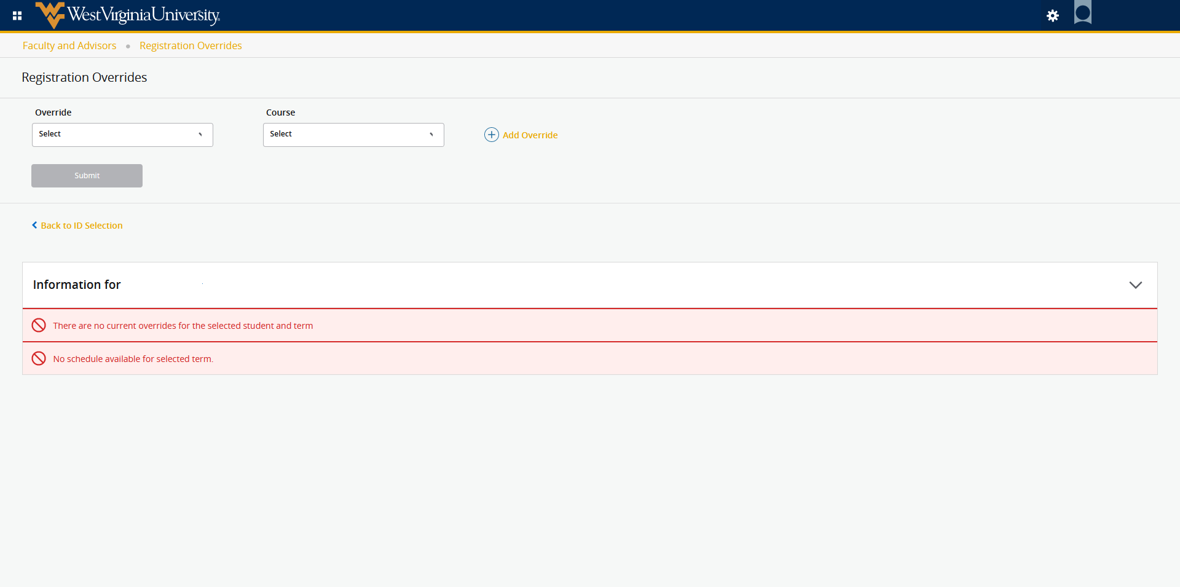
Student Menu – This information has been condensed into a new Student Profile. You can search for a student and view all relevant information on this page. Please note View Student Schedule is now Student Week at a Glance. There is also a new page, Student Registration History, which will allow you to view student registration information.
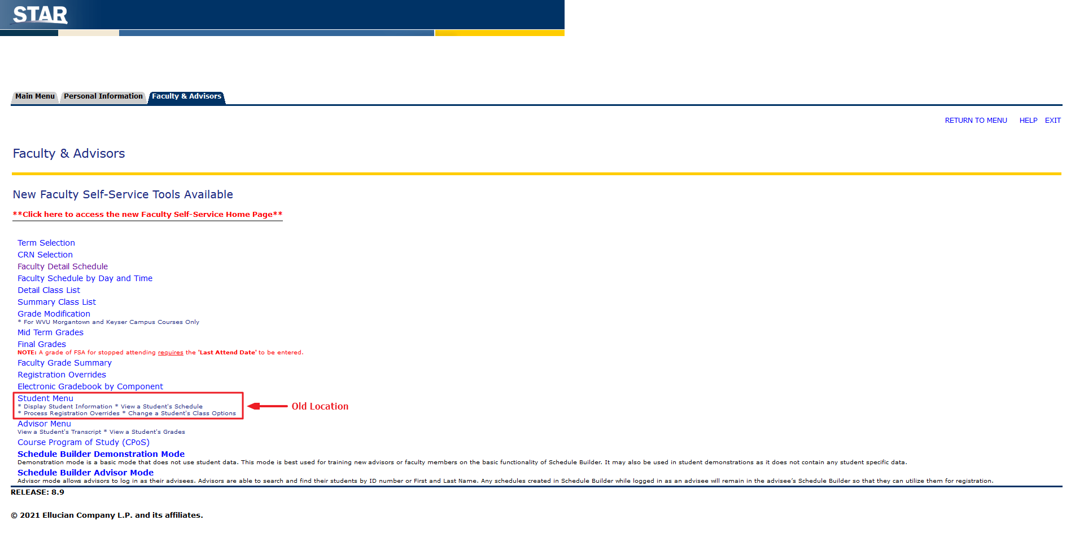
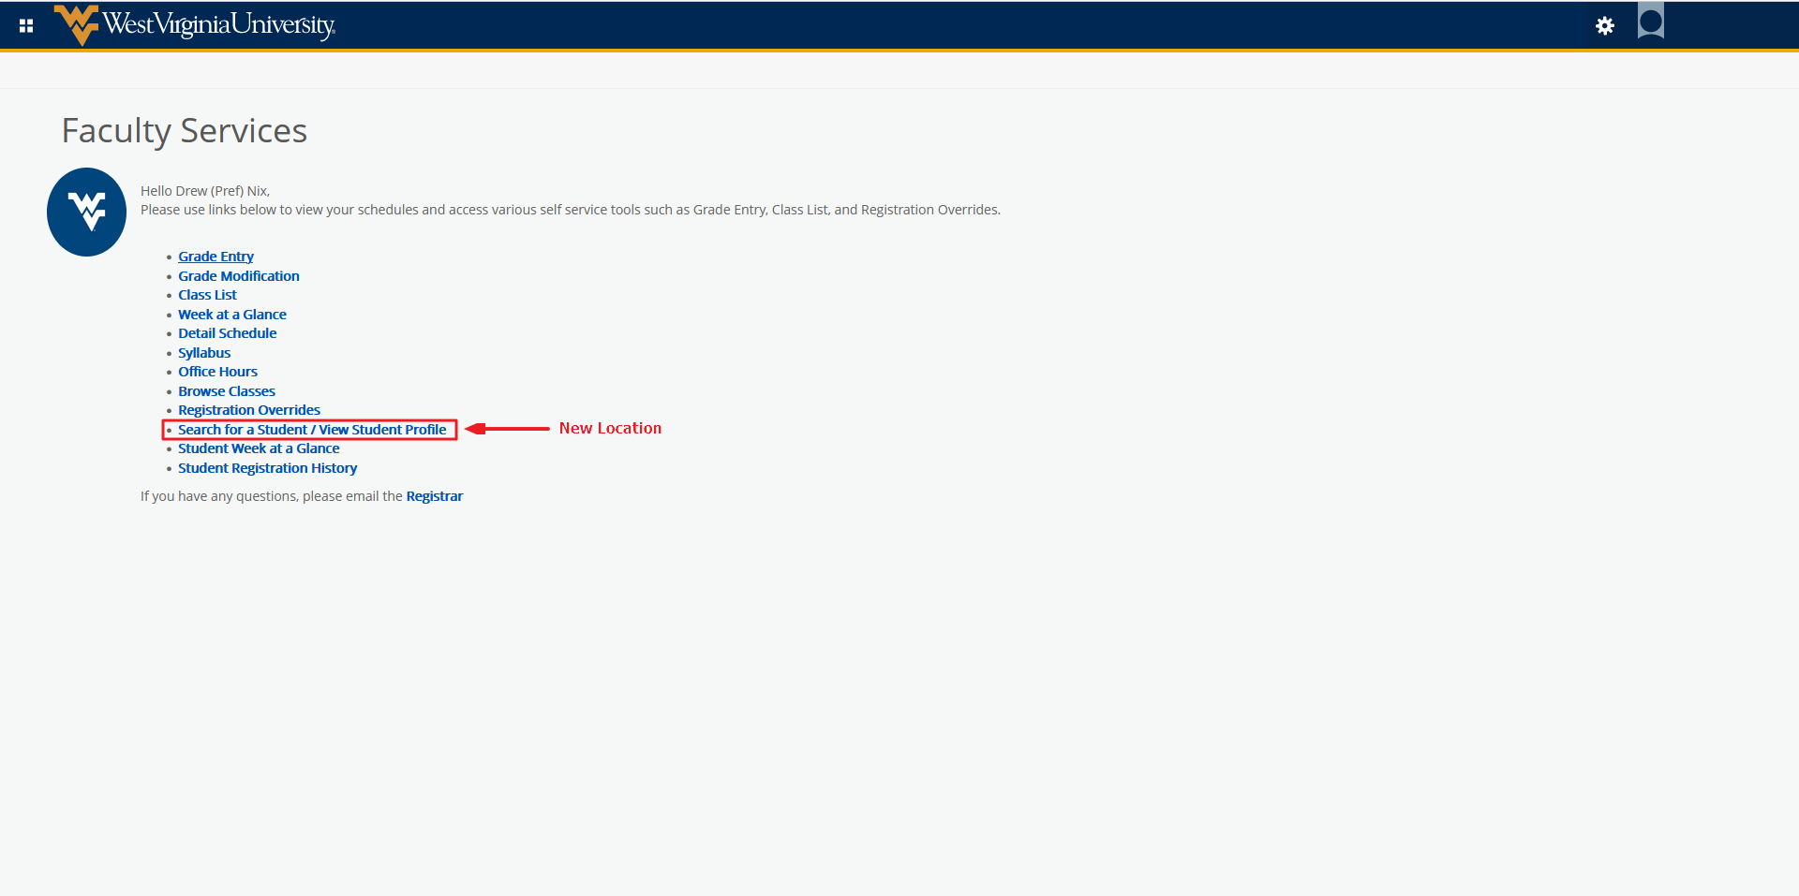
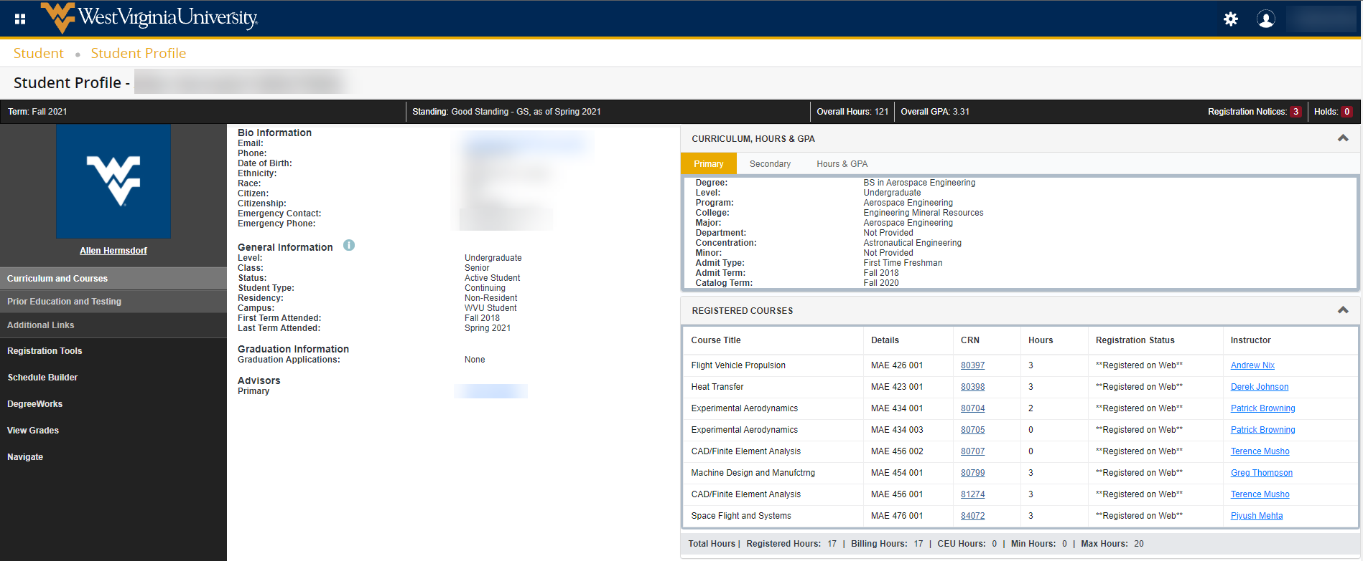

Advisor Menu –
Advisee Grade Summary – Search for the student and view their student profile, then on the left sidebar, select View Grades.
