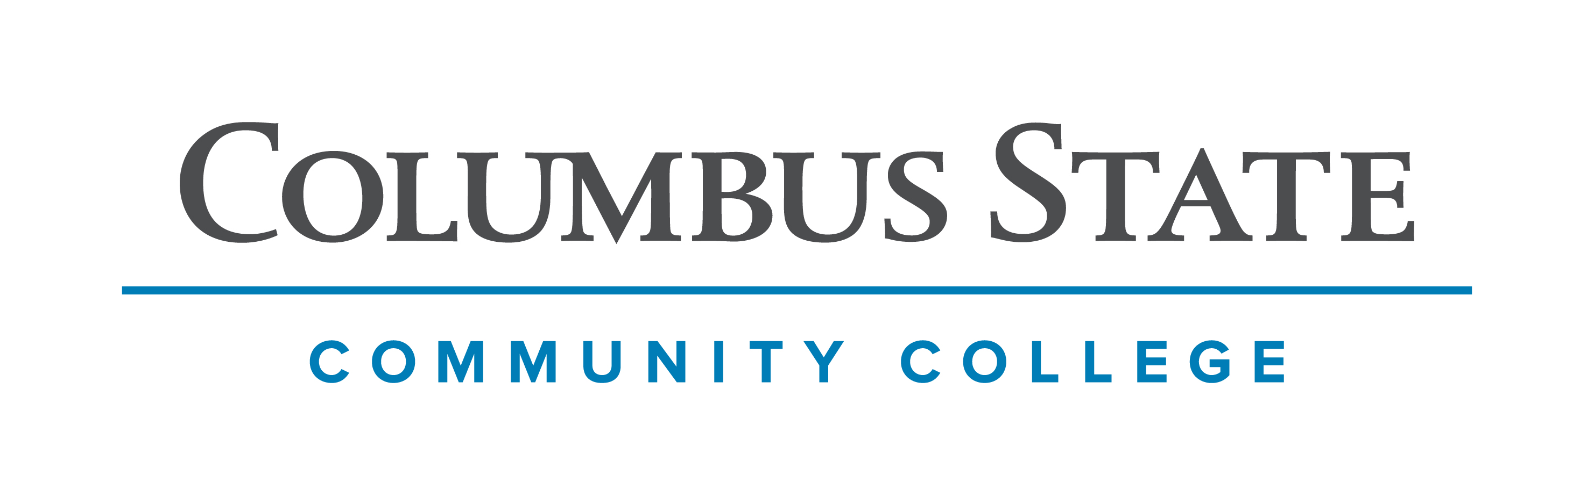
Columbus State Community College & West Virginia University
Associate of Arts leading to
Bachelor of Arts -Psychology (WVU-BA)
Addictions Study Minor
Suggested Plan of Study
Columbus State Community College | Hours | WVU Equivalents | Hours
Year One, 1st Semester
ENGL 1100 or ENGL 101 | 3 | ENGL 101 | 3
MATH 1148 | 4 | MATH 126 | 4
PSY 1100 | 3 | PSYC 101 | 3
*Visual/Performing Arts Elective | 3 | *Visual/Performing Arts Elective | 3
*Historical Study | 3 | *Historical Study | 3
COLS 1100 OR 1101 | 1 | ORIN 1TC | 1
TOTAL | 17 |  | 17
Year One, 2nd Semester
ENGL 2367 | 3 | ENGL 102 | 3
PSY 2325 | 3 | PSYC 251 | 3
*Visual/Performing Arts Elective | 3 | *Visual/Performing Arts Elective | 3
STAT 1450 | 4 | STAT 211 | 4
ASC 1190 | 1 | PHIL 1TC | 1
TOTAL | 14 |  | 14
Year Two, 1st Semester
*Natural Science with Lab | 4 | *Natural Science with Lab | 4
FOR LANG 1101 | 4 | FOR LANG 101 | 4
*Historical Study | 3 | *Historical Study | 3
PSY 2331 | 3 | PSYC 281 | 3
TOTAL | 14 |  | 14
Year Two, 2nd Semester
*Natural Science (No Lab) | 3 | *Natural Science (No Lab) | 3
FOR LANG 1102 | 4 | FOR LANG 102 | 4
*Social & Behavioral Science Elective | 3 | *Social & Behavioral Science Elective | 3
PSY 2340 | 3 | PSYC 241 | 3
*A.A Elective | 3 | *A.A Elective | 3
TOTAL | 16 |  | 16

WEST VIRGINIA UNIVERSITY
Year Three, 1st Semester |  | Year Three, 2nd Semester
FOR LANG 203 | 3 | FOR LANG 204 | 3
PSYC 203 | 3 | PSYC 204 | 3
COUN 240 | 3 | COUN 250 | 3
General Elective | 3 | COUN 340 | 3
General Elective | 3 | General Elective | 3
TOTAL | 15 | TOTAL | 15
Year Four, 1st Semester |  | Year Four, 2nd Semester
PSYC 301 | 3 | PSYC CAPSTONE | 3
PSYC 302 | 4 | PSYC CLUSTER A/B | 3
COUN 350 | 3 | PSYC UPPER DIVISION COURSE | 3
General Elective | 3 | COUN 440 | 3
General Elective | 1 | General Elective | 3
TOTAL | 14 | TOTAL | 15

Students must complete PSY 1100 with a C or better to be admitted to the Psychology program upon transferring to West Virginia University.

Although not required, students are encouraged to consider beginning or completing the PSYC 203 & 204 progression during the summer after graduating from Columbus State Community College. Doing so could create a lighter course load in the final semester and will also open up the possibility for a wider range of required upper division electives within the program.

Students completing degrees in WVU’s Eberly College of Arts and Sciences are encouraged to work with their advisors to integrate completion of an academic minor or minors into their programs of study, to the degree allowed within elective hours. WVU offers over 100 minors that complement major fields of study, build on students’ unique interests, expand perspectives, and broaden skills. See http://catalog.wvu.edu/undergraduate/minors/#minorsofferedtext for a list of available minors. Columbus State students may begin completion of certain minors at CSCC by utilizing ELECTIVE hours to take courses equivalent to the minor’s introductory requirements at WVU.

Students transferring to West Virginia University with an Associate of Arts or Associate of Science degree will have satisfied the General Education Foundation requirements at WVU.

Students who have questions regarding this articulation agreement or the transferability of coursework may contact the WVU Office of the University Registrar. All other questions should be directed to the WVU Office of Admissions.

The above transfer articulation of credit between West Virginia University and Columbus State Community College, is approved by the Dean, or the Dean’s designee, and effective the date of the signature.

_______________________________ _____________________________ ______________
Print Name Signature Date

Valerie Lastinger Ph.D. Associate Dean for WVU’s Eberly College of Arts & Sciences

